**The Wonder Factory - 2B**

**Conceptual Design Report**

**Fawaz Aladwani**

**Faisal Alfares**

**Abdullah Aljafaar**

**Abdulrahman Almohammad**

**Abdullah Bouhamad**

**2017-2018**



**Project Sponsor: The Wonder Factory (Jackee & Steve Alston)**

**Faculty Advisor & Instructor: Sarah Oman**

# **DISCLAIMER**

This report was prepared by students as part of a university course requirement. While considerable effort has been put into the project, it is not the work of licensed engineers and has not undergone the extensive verification that is common in the profession. The information, data, conclusions, and content of this report should not be relied on or utilized without thorough, independent testing and verification. University faculty members may have been associated with this project as advisors, sponsors, or course instructors, but as such they are not responsible for the accuracy of results or conclusions.

# 

# 

# 

# 

# 

# 

# 

# **EXECUTIVE SUMMARY**

The team’s project is to create an interactive, educational and entertaining system that would be a great addition to The Wonder Factory’s Science, Technology, Engineering and Mathematics (STEM) collection. This project focuses on the entertainment aspect of STEM, where the team has created an RGB LED that will be controlled by music. With this in mind, the team created this project where the project is an entertainment system built for the children to enjoy colorful lighting and control of shapes. The purpose is to present the concept of STEM in a way that would make children love education. Teaching kids about STEM should be done by making interact with the project. The electric keyboard which is the music source, would be like a control unit for the children to control the lights and shapes. The children will play on the piano, thus inputting sound signals into the sound sensor. The sound will indicate whether the servo motor will rotate or not, which will then reveal a shape corresponding to the key played. The project consists of several acrylic plates, where one of the plates is see through enabling the children to experience the live show of the LED changing colors. Connected to the LED will be an Arduino board which has the codes uploaded already and only needs a 9V battery to power it up. In addition to the LED, a servo motor that has the shapes attached to the rotating wings is also attached to the Arduino board thus being controlled by the uploaded program code.

This project uses the acrylic plates as a shield from any children to not disturb the wiring of the circuit. The plates are attached together creating a container, where it is beneficial for all the other components to be placed inside of the container. The LED is attached inside of a cylindrical shaped container, and attached on the side is the servo motor and having the shapes rotate in front of the cylinder thus covering up the light source exit and only projecting the cut out shapes. In addition, a sound sensor will be used to analyze the incoming sound of the musical instrument, where it is attached to the Arduino also and is placed on top of the musical instrument speaker. The other components such as the Arduino, the wiring and the batteries are placed inside the container and are fastened down in place thus reducing any detachment of any wires when moving.

Finally, the results are that the team made the LED change colors caused by sound from the musical instrument. The motor rotates and projects clear shapes onto the back surface of the container corresponding to the key played on the piano.

# 

# **ACKNOWLEDGEMENTS**

The team would like to acknowledge and give thanks to several Instructors that made this project possible.

Dr. Sarah Oman

Dr. Trevas

The clients Steve and Jackee Alston

Daved Willy

The Wonder Factory 2B team members appreciate every instructor who gave the team some of their spare time to help out in any way possible. The team asked for their help and they have never let us down, they were here for us for any issues that we faced during our ME476C and ME486C experience and with any issues faced with building this project.

# 

# 

# **TABLE OF CONTENTS**

DISCLAIMER…………………………………………………………………………………………….1

EXECUTIVE SUMMARY………………………………………………………………………………..2

ACKNOWLEDGMENTS…………………………………………………………………………………3

TABLE OF CONTENTS…………………………………………………………………………………4

1 BACKGROUND…………………………………………………………………………………6

1.1 Introduction………………………………………………………………………………………6

1.2 Project Description………………………………………………………………………………6

2 REQUIREMENTS………………………………………………………………………………..7

2.1 Customer Requirements (CRs)………………………………………………………………...7

2.2 Engineering Requirements (ERs)………………………………………………………………8

2.3 Testing Procedures (TPs)………………………………………………………………………9

2.3.1 Weight of the device…………………………………………………………………………….9

2.3.2 Durability………………………………………………………………………………………...10

2.3.3 Yield Strength of at Least 6 Mpa……………………………………………………………..10

2.3.4 Safety……………………………………………………………………………………………10

2.3.5 Aesthetic Appeal……………………………………………………………………………….10

2.3.6 Dimensions……………………………………………………………………………………..10

2.3.7 Power Requirement……………………………………………………………………………10

2.3.8 Cost………………………………………………………………………………………………11

2.4 Design Links (DLs)……………………………………………………………………………..11

2.4.1 Weight of the device……………………………………………………………………………11

2.4.2 Durability………………………………………………………………………………………...11

2.4.3 Yield Strength of at Least 6 Mpa……………………………………………………………..11

2.4.4 Safety……………………………………………………………………………………………12

2.4.5 Aesthetic Appeal……………………………………………………………………………….12

2.4.6 Dimensions……………………………………………………………………………………..12

2.4.7 Power Requirement……………………………………………………………………………12

2.4.8 Cost………………………………………………………………………………………………12

2.5 House of Quality (HoQ)………………………………………………………………………..13

3 EXISTING DESIGNS…………………………………………………………………………..13

3.1 Design Research……………………………………………………………………………….14

3.2 System Level……………………………………………………………………………………14

3.2.1 Existing Design #1: Discovery Place…………………………………………………………14

3.2.2 Existing Design #2: Discovery Children’s Museum…………………………………………15

3.2.3 Existing Design #3: The Thinkery…………………………………………………………….15

3.3 Functional Decomposition……………………………………………………………………..15

3.3.1 Black Box Model………………………………………………………………………………..15

3.3.2 Functional Model/Work-Process Diagram/Hierarchical Task Analysis…………………...16

3.4 Subsystem Level……………………………………………………………………………….17

3.4.1 Subsystem #1:Discovery Place………………………………………………………………17

3.4.1.1 Existing Design #1: Teaching Students……………………………………………………..17

3.4.1.2 Existing Design #2: Teaching Teachers……………………………………………………..17

3.4.1.3 Existing Design #3: Same Goal………………………………………………………………17

3.4.2 Subsystem #2: Discovery Children’s Museum………………………………………………17

3.4.2.1 Existing Design #1: Water World……………………………………………………………..18

3.4.2.2 Existing Design #2: Young at Art……………………………………………………………..18

3.4.2.3 Existing Design #3: It is Your Choice………………………………………………………...18

3.4.3 Subsystem #3: The Thinkery………………………………………………………………….18

3.4.3.1 Existing Design #1: Currents………………………………………………………………….18

3.4.3.2 Existing Design #2: Kitchen Lab……………………………………………………………...18

3.4.3.3 Existing Design #3: Light Lab…………………………………………………………………19

4 DESIGNS CONSIDERED……………………………………………………………………..19

4.1 Design #1: Solar energy car…………………………………………………………………..19

4.2 Design #2: Mathematics Board……………………………………………………………….20

4.3 Design #3: Railway Track……………………………………………………………………..21

4.4 Design #4: The Vortex…………………………………………………………………………22

4.5 Design #5: The Laser Show…………………………………………………………………..22

5 DESIGN SELECTED – First Semester………………………………………………………23

5.1 Rationale for Design Selection………………………………………………………………..23

5.1.1 Size………………………………………………………………………………………………24

5.1.2 Weight……………………………………………………………………………………………24

5.1.3 Safety……………………………………………………………………………………………25

5.1.4 Childlike Wonder and Operation Simplicity………………………………………………….25

5.1.5 Building Complexity…………………………………………………………………………….25

5.1.6 Interactive and educational……………………………………………………………………25

5.2 Design Description……………………………………………………………………………..26

5.2.1 Fritzing…………………………………………………………………………………………..27

5.2.2 3D Model………………………………………………………………………………………..29

5.2.3 Drawings………………………………………………………………………………………...30

6 PROPOSED DESIGN – First Semester…………………………………………………….35

7 IMPLEMENTATION - Second Semester…………………………………………………….38

7.1 Manufacturing…………………………………………………………………………………..38

7.2 Design Changes……………………………………………………………………………….38

8 Testing………………………………………………………………………………………….40

9 CONCLUSIONS……………………………………………………………………………….41

9.1 Contrib. to Project Success…………………………………………………………………42

9.2 Opport. For Improvement……………………………………………………………………43

10 REFERENCES………………………………………………………………………………..45

11 APPENDICES………………………………………………………………………………….46

11.1 Appendix A: Designs……………………………………………………………………….….46

11.2 Appendix B: Arduino Code (Sound Detection Sensor)………………………………….…48

11.3 Appendix C: Pugh Chart……………………………………………………………………….56

11.4 Appendix D: Bill of materials………………………………………………………………….62

**1**  **BACKGROUND**

## **1.1** **Introduction**

The Wonder Factory STEM Display project is about introducing a uniquely new design into the Wonder Factory collection. To begin with, the Wonder Factory is a science and engineering centre located in Flagstaff, Arizona. It serves as a home to different display of ideas as a combination of STEM (Science, Technology, Engineering, and Mathematics). The main goal behind the project is to generate a number of display ideas that can be functioned in an interesting and interactive approach. The project will be sponsored by The Wonder Factory founders (Jackee and Steve Alston) and it will be of interests to them because they are eager to add up a new design into their collection. The project will be beneficial to the sponsor and stakeholders in terms of allowing Wonder Factory visitors, from young kids to parents, to interact with the displayed idea and get inspired by it. They will be able to learn new information regarding STEM as well as having fun with their time doing so. Moreover, they will be transported into being engineers or scientists all through their visit and knowledge gained while interacting with the ideas.

## **1.2** **Project Description**

The project is heavily based on besting a learning experience to kids and offering them a chance to think deeply about certain displayed everyday objects. The Wonder Factory's goal is to lead the next generation of young minds into serving a chair for them to be the engineers, artists, scientists, and thinkers of the future. All of that through the displayed interactions with technology, science, mathematics, and engineering. The sponsor’s original project description can be viewed as follows,

“ Our mission at The Wonder Factory is to generate learning through play. We feel passionately that the next generation must be given opportunities doe hands-on, interactive experiences to take their positions as the thinkers, the makers, and the creators of the future. Your task is to generate lots of interactive display ideas and to ultimately design and test one final display ready for public consumption. The client criteria for the design must be:

1. Safe to operate
2. A celebration of a child-like wonder (i.e. have a wow factor)
3. Tactile, auditory, and visual as possible
4. As simple to operate as possible
5. Portable, with a weight restriction under 100 Ibs. per individual piece and take up floor space no longer than 100 square feet
6. Designs should be places where a visitor can project themselves into the role of that reality as much as possible (i.e. They should see themselves as an engineer, a scientist, a storyteller, a medical professional, naturalist, or an artist.)
7. Empower visitors to “fee” smart so they will excel in perpetuity
8. Be able to entertain multiple visitors, though this isn’t mandatory”

# **2 REQUIREMENTS**

In this section both the customer requirements and engineering requirements have been discussed. One of the major aims of the project is to ensure that the requirements, which were presented by the clients, are fulfilled in an exhaustive manner. In this case, the team will make sure that both the customer and the engineering requirements are met. This will be of great significance since it will ensure that the team in the long run comes up with an efficient final design.

## **2.1** **Customer Requirements (CRs)**

The team will derive its customer requirements from the requests, which were given by the clients and the users. The clients in this case are sponsors Jackee and Steve Alston and the Wonder Factory. The Wonder Factory is a science community located in Flagstaff, Arizona. The clients are best suited in giving the requirements since they know exactly how the design will help them in their operations. In addition they are the ones who will use the instruments most of the time. The crucial customer requirements are shown in the table 1 below.

Table 1 - Customer Requirements

|  |  |
| --- | --- |
| Customer requirement | **Description/ importance** |
| Interactive | The design should ensure that the users engage in a lot of activities hence ensuring that they learn a lot of things within a short period of time. |
| Educational | This will ensure that users learn new things during the time they are using the device |
| Safe | The device should be safe to avoid posing any danger to the users by not having sharp edges. |
| Easy to use | The design should not be complicated so that the users will have an easy time in operating it. |
| Portable | This will ensure that the users carry the device easily from one point to another. |
| Childlike wonder | The device should be attractive and physically appealing so as to make it wonderful to the users. |
| Auditory and visual | It should have audio and visual output so that the users can both hear and see the various operations they engage in. |
| Project themselves into a role | This will ensure that the user engages in an initial role which will be accomplished in the end. |
|  |  |

## **2.2** **Engineering Requirements (ERs)**

After obtaining the customer requirements the team will then be tasked with the development of appropriate engineering requirements. This is crucial since it assures improvement of the original design. The major reason for formulating these engineering requirements was to attain target values which are measurable for each of the developed CRs and hence avoid wasting of time during the project

**Table 2: Engineering requirements**

|  |  |
| --- | --- |
| **Engineering requirement** | **Targets** |
| 1-Weight | After completion the device should not exceed the weight of 22.046 lb. |
| 2-Durability | The materials used should ensure that the device lasts for a long period of time. |
| 3-Strength of the device | The device should yield a strength of at least 12 volts. |
| 4-Safety | During designing sharp edges should be avoided to avoid putting the lives of the users at risk due to injuries inflicted. |
| 5-Aesthetic appeal | The painting adopted should be bright so as to make the device attractive to the users. |
| 6-Power requirement | The device should not exceed a maximum power output of 500 watts. |
| 7-Dimensions | The dimensions of the device should be 19.685 in x 19.685 in x 19.685 in. |
| 8-Cost | The entire project should not exceed $400. |

## **2.3 Testing Procedures (TPs)**

## In order to ensure that the device met the engineering requirements there is need to subject it to a variety of tests. The tests are of great significance so as to ensure that the set limits and standards are not exceeded. The testing procedures performed are as discussed below.

## **2.3.1 Weight of the device**

## From time to time the device was hanged on a spring balance to make sure that it did not exceed the weight of 22.046 Ib. After measuring the final design it weighed 15.432 Ib and hence it was within the required weight limits.

## **2.3.2 Durability**

## The materials which were used were of high quality to ensure that the device lasted for a longer period of time. In this regard, high quality plastic with a substantial thickness was used. Also the glass used was of high quality.

## **2.3.3 Yield strength of at least 6 Mpa**

## In order to determine the yield strength of the material used to make the device is subjected to a force. In this regard, the device was clamped and subjected to a particular maximum weight. A conclusion was made that the materials were strong since the device was able to withstand that weight.

## **2.3.4** **Safety**

## Safety was a crucial factor and hence no chance was left for protruding sharp parts. In this regard, the team avoided sharp edges and corners. The protruding screws and bolts were grinded to ensure a smooth finish is attained.

## **2.3.5** **Aesthetic appeal**

## Aesthetic appeal is very crucial in boosting the self esteem of users. In this regard, the device was painted with a yellow color and stickers of inspiring cartoons were used.

## **2.3.6** **Dimensions**

## The dimensions for our box the sides 26 x 26 in, the back and front 26 x 26 in, and the top 26 x 26 in.

## **2.3.7** **Power requirement**

## A wattmeter was used to measure the power output to ensure it did not exceed a maximum of 500 watts.

## 

## 

## **2.3.8 Cost**

## A budget regarding all the materials which were used in the entire project was drafted and

## **2.4 Design Links (DLs)**

## After completing the project, the results obtained by the team were compared with the engineering requirements to determine whether they were fully met as required. The design links are as discussed below.

## **2.4.1** **Weight of the device**

## In the design of this device, weight is a crucial factor of consideration since it ensured that the users were able to move the device from one place to another with ease. In this regard, each material which was to be incorporated in the device was measured using a spring balance and a total made. For those components which seemed to increase weight, alternatives were found. The maximum weight of the device was to be 10 Ib**.**

## **2.4.2** **Durability**

## In order to ensure that the device served the users for a long period of time, the team ensured that the materials used were of high quality. Hard and thick plastic and glass were used in this regard. Areas which were prone to lasting were painted. The joints were fixed in a tight manner to avoid constant movement especially while using and moving from one location to another.

## **2.4.3** **Yield strength of at least 6 Mpa**

## In order to determine the yield strength of the material used to make the device it subjected to a force. In this regard, the device was clamped and subjected to a particular maximum weight. A conclusion was made that the materials were strong since the device was able to withstand that weight.

## 

## **2.4.4** **Safety**

## The users of the device should feel comfortable while using the device and one way of facilitating this is ensuring that their safety is guaranteed. The team ensured that the final design did not have any protruding sharp edges which could injure the users. However, areas which appeared sharp were rounded and smoothened through grinding.

## **2.4.5** **Aesthetic appeal**

## While using the device, the users feel motivated due to its aesthetic appeal. In this regard, the device was painted using a bright yellow color and cartoon stickers used to increase its aesthetic appeal. In addition, the audio visual system plays a crucial role in ensuring aesthetic appeal since the users are able to follow the progress of the role at hand.

## **2.4.6** **Dimensions**

## When the team measured the length, width and height of the final design, they realized that it was 19.685 by 19.685 in by 19.685 in, but we did some changes so the sides, back front, and the top have the sames dimensions its 26 x 26 in for all the plates. The final design for the box will look like a square. The new dimensions reveal that they were perfect in their measurements. The dimensions are crucial in ensuring that the box can easily be stored in its designed storage compartment.

## **2.4.7** **Power requirement**

## The way to avoid unnecessary usage of power the team ensured that the total number of components used did not exceed 500 watts. A wattmeter was used to measure the power output of various components.

## **2.4.8** **Cost**

## The team drafted a budget which was divided into two parts namely: the actual expenses and the anticipated expenses. The total cost amounted to $ 420.68. This cost was within the projected budget range of $500.

## 

## **2.5** **House of Quality (HoQ)**

The purpose of house of quality is to show the relationship of the customer requirements and the engineering requirements. In this regard, ever customer requirement is given a weight and then related to the corresponding engineering requirements.

Figure 1- House of Quality

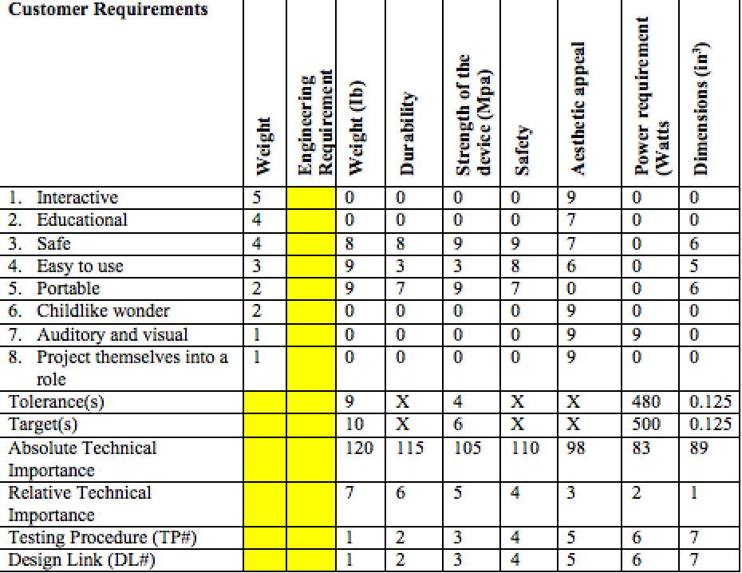

# **3** **EXISTING DESIGNS**

For the project to be at its best potential and reach the best of its expectations, research needs to be done on some existing designs. The research done was based on similar features The Wonder Factory has, such as exhibits made for children that offers STEM based displays that educates, entertains and inspires them. This section provides a detailed overview of the research process and its outcomes.

## **3.1** **Design Research**

The Wonder Factory’s purpose is to offer children a chance to try out different STEM displays, and when wanting to research about existing designs that educate children, keywords such as educational, interactive and attractive displays are used. As part of the research, the team’s meeting with the clients was an essential part of the research to gather as much information about the goals and purpose of the Wonder Factory. From this meeting the team needed to know what kind of STEM displays they had in the exhibit, and what are their requirements for the display, in terms of complexity and being interactive. From that, a thorough research process can be done by the team. Based on the client/team meeting, information about the exhibit that will be in Northern Arizona University campus has been given, where the team will go and observe on the 4th of March 2018, and would take notes on how The Wonder Factory really works. This observation of The Wonder Factory on-site visit holds as a big part of the research and will help the team on designs in the future. Exhibits that has the same goals as The Wonder Factor are many, and part of the research process was to locate as many as the team could online, and then compare them with The Wonder Factory, this process would help the team in regards to the benchmarking.

## **3.2** **System Level**

The research that was done resulted in finding three existing designs that share similar goals, which is to educate young minds through interactive STEM displays. The team would be designing a STEM based display that would be a great addition to The Wonder Factory, therefore focusing on other exhibitions is essential, to compare creativity and quality of the displays, so that the team’s design would be a great addition The Wonder Factory. The following section provides the three existing designs that have been found during research.

### **3.2.1** **Existing Design #1: Discovery Place**

The Discovery Place museums are built to inspire people, it is a place for learning, entertaining, and creativity. “We inspire curious thinkers to discover the wonders of science, technology and nature” [1]. This quote was found on the Discovery Place museums website, where it clearly shows the purpose of the museum, and how this type of learning is used to educate people. The Discovery Place museums relates greatly to our requirements for The Wonder Factory in terms of education and inspiration using STEM based displays.

### **3.2.2** **Existing Design #2: Discovery Children’s Museum**

The Discovery Children’s Museum is a great place to take children with different dreams, and who have a specific thing they have to do to enjoy their time. The museum offers several exhibits to the visitors where the visitor can choose to be in an exhibit that has interactive display ranging from an health education exhibition to a water based education exhibition. The Discovery Children’s Museum makes the children actively engage in entertaining learning experiences [2].

**3.2.3**  **Existing Design #3: The Thinkery**

The Thinkery, located in Austin,TX, is a place similar to the Wonder Factory where it allows children to try and experience many STEM based displays. What also makes The Thinkery a museum that the team could learn from is the number of exhibitions and the type of displays the museum has. This information is helpful when identifying the type of displays a child likes, where also this information can clarify the level of creativity the teams needs to be thinking about.Their vision is to have a community that wants to keep learning and discovering [3].

## **3.3** **Functional Decomposition**

Breaking down the problem we are trying to solve is a process that will help the team accomplish tasks easier and will even produce more efficient results. The following section provides the black box model created and the functional decomposition for the Wonder Factory.

### **3.3.1** **Black Box Model**

A black box model identifies the overall function of the project, in this case it is the Wonder Factory. For the overall function to happen, inputs and outputs for the material, energy and signal needs to be identified.

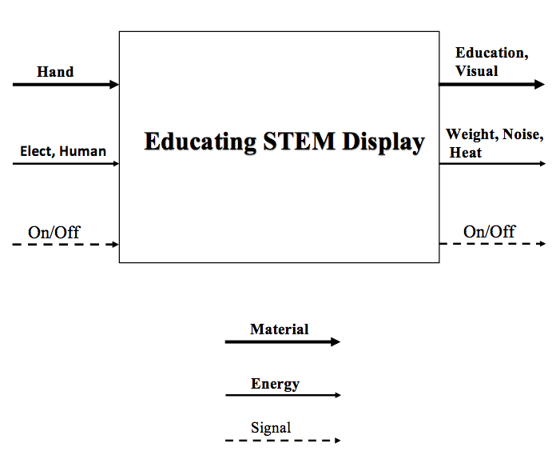

### 

### 

### 

### 

### 

### 

Figure 2- Black Box Model of the Wonder Factory.

As shown in Figure 2, the overall function of the Wonder Factory is to be educated by the STEM display. This black box model helped the team first identify the purpose of project, next is to identify the inputs and outputs, because the Wonder Factory is an exhibit filled with interactive STEM displays, then the input should be the user’s hand. Many displays are electrically driven thus making the input for the energy part of the black box model electrical and human. This part of the black box model was important to clarify where the team could use this information in future designs.

### **3.3.2** **Functional Model/Work-Process Diagram/Hierarchical Task Analysis**

The functional decomposition is way for the team to clarify the main features the Wonder Factory has, and identify the important tasks the team needs to focus on. As shown in Figure 3, Important features the Wonder Factory is looking for in their STEM displays are shown, such that a display should be both educational and interactive, next is to have the display inspiring the children by educating them about basic theories of science, technology, engineering and mathematics.The way the team is using the functional decomposition is by assigning certain tasks for each team member that are shown in the functional decomposition By doing this we are satisfying all of the customer requirements, and on top of that, the team member that had been assigned the task will focus on the task and their main goal is to produce efficient results.

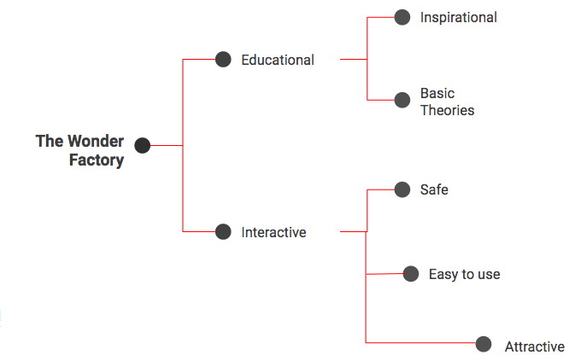

Figure 3- Functional Decomposition breaking down important features of the Wonder Factory.

## 

## **3.4** **Subsystem Level**

Using the existing designs listed in section 3.2, the team has thoroughly researched more about the designs and tried to focus on what they have that relates heavily to the important features shown in Figure 2. The team is looking for the educational features and the interactive features the existing designs might have. The following section provides what three sub-designs from the existing designs that can help and relates to the wonder factory.

### **3.4.1 Subsystem #1: Discovery Place**

In our functional decomposition we trying to focus on how important to make it interactive and useful in same time. In functional decomposition we are trying to improve the main goal and produce efficient results.

#### **3.4.1.1 Existing Design #1: Teaching students**

As a team we trying to teach the students how to solving problems by using technology and interactive them to learning a new things about wedorfactory.

#### **3.4.1.2 Existing Design #2: Teaching teachers**

We want to teach teachers how to get the students attention by using entertainment industry more than theoretical education, so the students will not get bored.

#### **3.4.1.3 Existing Design #3: Same goal**

We have same goal as Discovery Children’s Museum to encourage children to participate in entertaining learning experiences.

### **3.4.2** **Subsystem #2: Discovery Children’s Museum**

The Discovery Children’s Museum is the best place for children to improve their skills and useful for children to spend their time with something could be more advantageous for them in the future. Even though, the Discovery Children’s Museum has many different types of education like WATER WORLD, YOUNG AT ART, and IT’S YOUR CHOICE…. and children can choose and what they prefer.

#### **3.4.2.1 Existing Design #1: Water World**

#### “Visitors play and work with water in a variety of hands-on ways: launching balls into winding tracks, guiding boats through a lock system, fitting together plastic pipes to redirect flow, feeding a vortex or using air blowers to create currents” [2]. We think that children won’t be bored by playing with water using their hands and they can be learn how use the water for useful things.

#### 

#### **3.4.2.2 Existing Design #2: Young at Art**

We like this activity because we can understand how children think by drawing their ideas. “Visitors explore the “language” of art through hands-on investigations of the elements of art: color, line, shape, texture, space and form. Surrounded by whimsical wall murals, visitors explore each of the elements of art through interactive components, and also combine the elements into unique, individualized artworks at “creative stations” throughout the gallery”[2].

#### **3.4.2.3** **Existing Design #3: IT’S YOUR CHOICE**

We should allows children to make many choices about their health and they can get an experience how to choose the correct thing about their health. “This experience is a health education exhibition designed to increase the awareness and understanding of the choices kids and families make every day that affect their health”[2].

### **3.4.3** **Subsystem #3: The Thinkery**

The thinkery is a great place for children to also have a lot of fun, learn, and get an experience. Children can play and by spending time with new ideas makes children creative, artistic, and originative. The Thinkery also has many activities like Currents, Kitchen Lab, Light Lab and many.

**3.4.3.1 Existing Design #1: Currents**

Children can figure out what are the concepts of fluid dynamics and how it work in the same time they can learn what is the connections between water and sound so, they can get more advantageous about this activity with a new and interactive thing.

#### **3.4.3.2 Existing Design #2: Kitchen Lab**

It is important to let children know about chemical reactions and edible minerals. It’s great to make children explore how to be advantageous by using this materials correctly.

#### **3.4.3.3 Existing Design #3: Light Lab**

We can teach children how to use electrical energy by drawing, play and control hues with circuits and manufacture light structures utilizing magnets and smaller than expected squares with using LED so they can understand how they can make useful things.

# 

# **4** **DESIGNS CONSIDERED**

At the beginning, the team have thought of every idea we could design and build. Every member of the team thought about at least six different ideas. We met the client and we discussed with her our ideas then she elected five designs. She also discussed the factors that we need to consider when we choose the design we are building. We outlined each idea with its advantages and disadvantages. This helped us to choose the best design to build. In the following sections you will see four examples that the team considered and the chosen design to build.

## 

## **4.1** **Design #1: Solar energy car**

The idea was to design and build a car that is powered by solar cells attached to the roof of the car. The solar panels transforms the solar light into electric energy and then stores it in batteries placed in the trunk. A child would drive the car and learn that the solar energy could be used to generate electricity and use it to move the car.

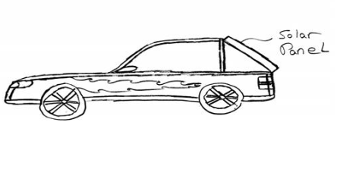

Figure 4 - A sketch of the solar energy car design

This design has some advantages. It could be a good way to educate the children, as they can actually drive the car and feel the energy. It is also easy to use; all what he needs to do is to get in and step on the pedal.

There are also disadvantages. It is dangerous for an eight years child to drive a real car. He might get involved in an accident and have a real injury. Also to build a car, you will need a big budget. In our case, we were on a tight budget; less than two thousands dollars. It would also be above the required weight and size, which should be less than 100 sq ft and 100 lbs. Lastly; the experiment would allow for one user at a time. In this case it will time consuming to have all the kids’ turns.

## **4.2** **Design #2: Mathematics Board**

This design has a long platform that include different values holes. It allows from one to three kids at the same time to throw multiple balls, each kid has a different balls color, and the first child to reach a hundred total score wins.

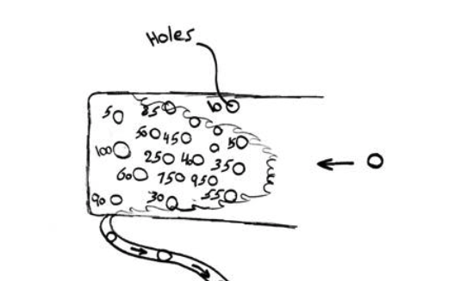

Figure 5- A sketch of the mathematics board.

The good idea of this design is that it was both educational and fun at the same time. The kids could play with it, challenge each other, and also learn to sum the scores they have reached and how much more they need to win. It can have more than one child to play at once, so they can challenge each other and still have time for all of them to play. And the most important thing is that it safe and harmless on them.

This design could be expensive to build. We would need more than two thousand dollars to build the machine. It would also be too heavy, as we assumed it will weigh more than 100 lbs. The machine wouldn’t be easy to move; as it is too heavy and large.

## **4.3** **Design #3: Railway Track**

The experiment is made of a railway track, and four toy cars with four remotes, each to control the speed of each car. Four kids would use the remotes to have the cars to complete the lap by adjusting their speeds on the curves. Whoever reach the end line safely will be the winner.

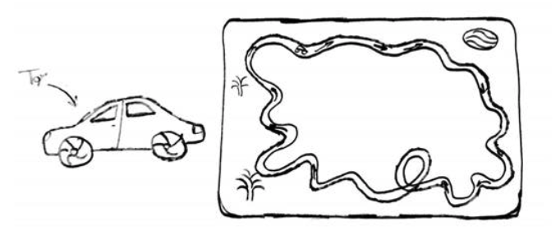

Figure 6- A sketch of the railway track idea.

It is enjoyable that they can challenge each other. Also, it serves in warningly creative way by informing the children that speeding could be very dangerous. It shows that speed isn’t a solution to reach your destination quickly using the following equation;

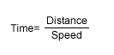

Equation 1- To calculate time.

Applying a constant distance of 20 miles. If you were driving with speed of 40 mph, it will need 30 minutes to reach your destination. However, if you rise your speed to 60 mph, you will reach your destination in 20 minutes. So the difference would be 10 minutes, so whatever speed you drive, it wont be more precious than your safety.

The design was also expensive and it is too big to build. It isn’t handy or portable.

**4.4** **Design #4: The Vortex**

The design is made of an electric motor that is attached to a fan. The fan is attached at the bottom of the water tank and the motor is controlled by a remote. Once you turn on the motor, a vortex will be formed. This can teach the kids that an electric power can be transformed into a mechanic energy.

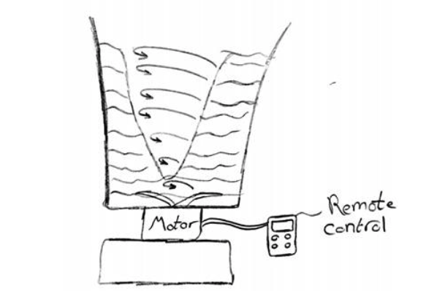

Figure 7- A sketch of the water vortex generator.

The project would be as safe as it possible. Since the tank is deep enough, we will make sure that the fan wont hurt the children. Also it has the appropriate size and weight that we can carry it around without any obstacles. It doesn’t cost a lot as everything is made out of plastic and wood. The most expensive part would be the motor, but it is not too expensive since it is only a small motor than can be found in any old toy.

We found that the project isn’t creative enough for the children to enjoy. All what they are going to do is hit a button and watch the water move around. It will cost them few seconds to get bored of it. It won’t catch their attention as they need something to interact with. Finally, only one button need to be pressed, so one kid would press it at a time.

## **4.5** **Design #5: The Laser Show**

The design is made primarily of piano. Each button is attached to the speaker with its own tone and it is also attached to the laser with a specific frequency wave. It teaches the kids that each sound in the universe has a different frequency wave.

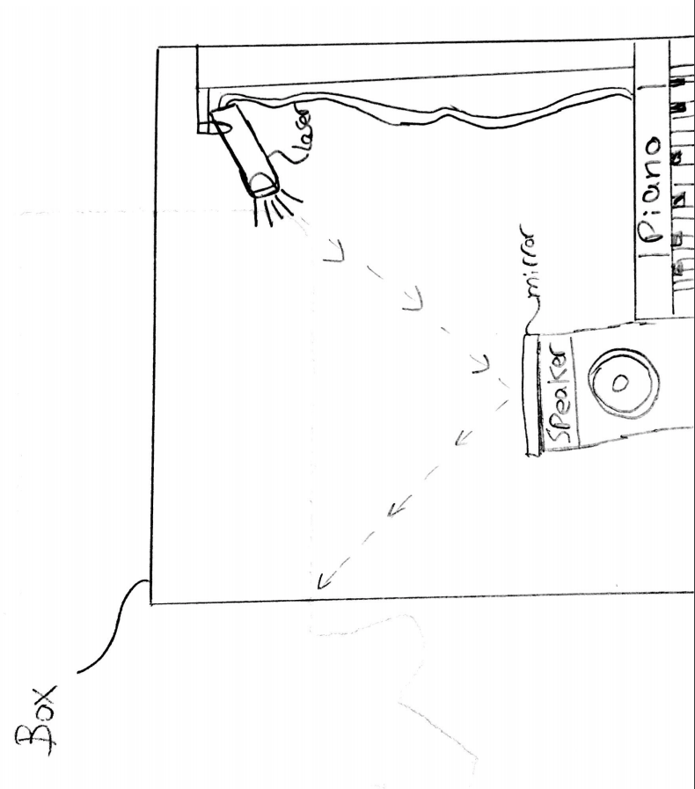

Figure 8- A sketch of the laser show idea.

The design is a perfect way to teach the kids about frequencies and how they have different wave shapes. It is also enjoyable and fun way to learn. They can enjoy playing the piano and see how the laser waves change with each tone. It won’t cost a lot to build, it is guaranteed that it won't cost more than two thousands dollars. The only issue is that it doesn’t allow for multiple users to play with.

# **5** **DESIGN SELECTED – First Semester**

The selection process of a design that fulfills every requirement made by the client and the team, is a process that needs to be thoroughly executed. This section presents this process and how the team used these requirements to choose one design that satisfies the client’s and team’s needs. From this selection process, it is indicated that the best design to go with was the laser show project, where when using the factors presented in the decision matrix, the laser show had the highest score out of the rest of the designs. Moreover, in our opinion it holds the highest value of both education and enjoyment out of the presented designs the most.

## **5.1** **Rationale for Design Selection**

The design selection process needs to be done by first knowing the important factors and features the final design should have, such as the client’s requirements. The following list is of the client’s requirements showing the important requirements:

1. **Safe to operate**
2. **Educational**

Importance

1. **Interactive**
2. **Childlike wonder**
3. **Easy to use**
4. **Portable**
5. **Auditory and visual**
6. **Project themselves into the role**

### **5.1.1 Size**

The 10 factors that needs to be focused on are shown in Table 3, where these factors will help with the selection process. First of all, the size factor, where the size of the project matters because of the portability importance. This project needs to be easily transported from one location to the other with no hassle, which also means it needs be lightweight. When evaluating the solar energy car, the size was a big issue for the team, where this project needs space when completely built. The second project is the math board, the size had a result of 9, meaning it is a big issue when coming to size. The next project evaluated is the railway track, where to efficiently build this track, it needs a large area. The vortex project was smaller in size from the other three, where it has a result of 6, which means its size is good but not great, where the best result is getting a 3. The vortex needs a smaller area because it does not require large sized components nor space to perform its actions. Finally the laser show, this project when imagining its final design, the team thought about the length it needs to project the lasers, thus it got a size value of 6.

### **5.1.2 Weight**

When evaluating the solar energy car, math board, railway track, the vortex, and the laser show for weight, the team used the weight and number of components a project has an approximation on which project may weigh most. The components on the solar energy car are many, and in addition to the battery that is needed to be implemented onto the solar car, important components such as the wheels, steering wheel and the solar panels are heavy. From this, the solar energy car scored a 9. The math board requires a hard surface, meanings material that has a high density thus increasing its weight. The railway track weighs a lot because of its surface area, where the material that will be used may make the project heavy where it will be used for the whole track. The vortex is lighter, where the only heavy component in this project is the water located in the glass jar. For the laser show project, any material could be used as the container that will allow every other component to be stationed inside.

### **5.1.3 Safety**

The most important client requirement is the safety of the project, this factor was weighted with 5 points, showing that it will affect the final results of the decision making. The two projects that scored the highest in safety were the math board and the laser show, where both scored a 20. This score was given because of the project not contain any dangerous components that may harm the children. The math board will only require the children to throw a ball, and the laser show will only require the user to play a musical instrument, thus having a high factor of safety.

### **5.1.4 Childlike Wonder and Operation Simplicity**

The childlike wonder factor is also important, where this whole project would be an addition to the Wonder Factory in Flagstaff, AZ. This means the project needs to attract the children and look interesting to them, and the laser show project had the highest score as seen in Table 3. The reason behind this is the visual and auditory features the laser project presents to the children, where a musical instrument will be controlling the lasers. The next factor is the simplicity of the operation, where the most easiest project to operate was the laser show. This is because the project will be used by children, meaning the need of non-difficult or confusing steps are important. The laser show is a one step process, this process initiates the other steps until the the laser projects onto the opposite surface.

### **5.1.5 Building Complexity and Cost**

Building the project is another factor that needs to be taken under consideration, where this will show whether the project could be completed and done before the deadline. The railway track had the best score in this category, where the project is not complex to build, and in the other hand the the laser show is the most complex project to build from all of the other projects.The cost factor is also important, where the team is limited to the budget provided, meaning the cost of parts should be appropriate so that the project could be built.The laser show, the vortex, the railway and the math board all scored the same, but the solar energy scored the highest where the components are costly.

### **5.1.6 Interactive and Educational**

Another two important factors that the client specified on is making the project interactive and educational, because this project will go into the STEM exhibition. The laser show scored highest in these categories, and in addition to the advantages specified in figure 8, the laser show provides a musical instrument to the children allowing the to interact with the project.

Table 3- Decision Matrix

## 

## 

The pugh chart also helped with the decision making, this pugh chart is in Appendix C. The pugh chart contains the important criterias the team thought of that will help with the decision making.

## **5.2 Design Description**

Designing our initial sketched idea and bringing it to life surely required us to work on different types of programs and softwares. We created detailed 3D images of our main design with it’s parts assembled that were mainly made from everyday materials like plastic and glass to adding different kinds of electrical circuit tools that we had to read through for the first time. To begin with, we started out with buying an arduino that we have found online for how much of a main effective part it holds. Next, we consulted our client to get their approval of purchasing. We purchased the arduino along with valued resistors (330 ohms), jumper wires, two types of LED lights (Red & Yellow), and a microphone. Initially, we wanted to test out the circuit and how well it might function as a platform to launch the lights and detect sounds. Figure 9 shows our circuit set up with all the tools added and connected to the arduino.

### 

### **5.2.1 Fritzing**

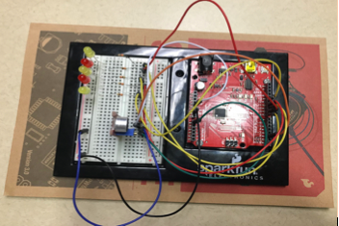

Figure 9- Circuit set up

Upon meeting with our instructor, he suggested different kind of applications that might help us with our circuit. Applications like p-splice, Eagle, and Fritzing would come in handy in regard to performing the schematics. Settling down on Fritzing, we were able to translate the data set up from the created circuit and implement it as a Fritzing schematic. Fritzing allowed us to select each component from the circuit and adjust it based on color, value, or length. Thus, shaping a replica of the circuit as a computer sketched image. Figures 10 and 11 display the fritzing schematic that represents the project’s circuit.

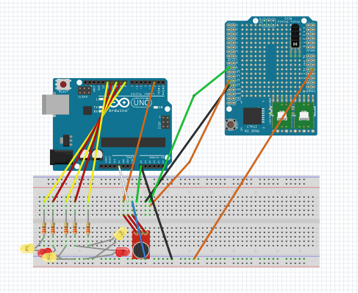

Figure 10- Fritzing

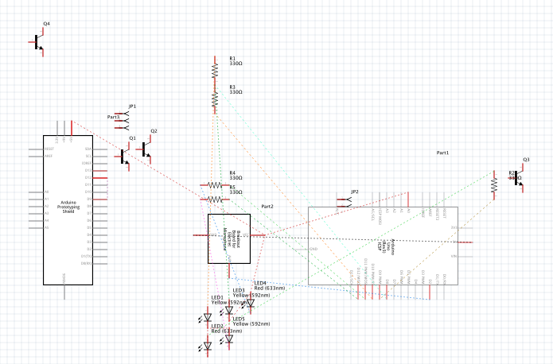

Figure 11- Fritzing Schematics

Later, we designed a 3D-model of our design using SolidWork. This helped us check different views of our design and observing how much big or small each side should be through selecting different dimensions to each part. Recalling what we have purchased, the plastic will be covering the top, bottom, and sides of the box. As for the glass, it will be covering the front view of the box. Adding to the front view is a platform that we will be using to lay the piano on. Figure 11 concludes the outside shape of our design with arrows pointing on the materials applied.

### **5.2.2 3D Model**

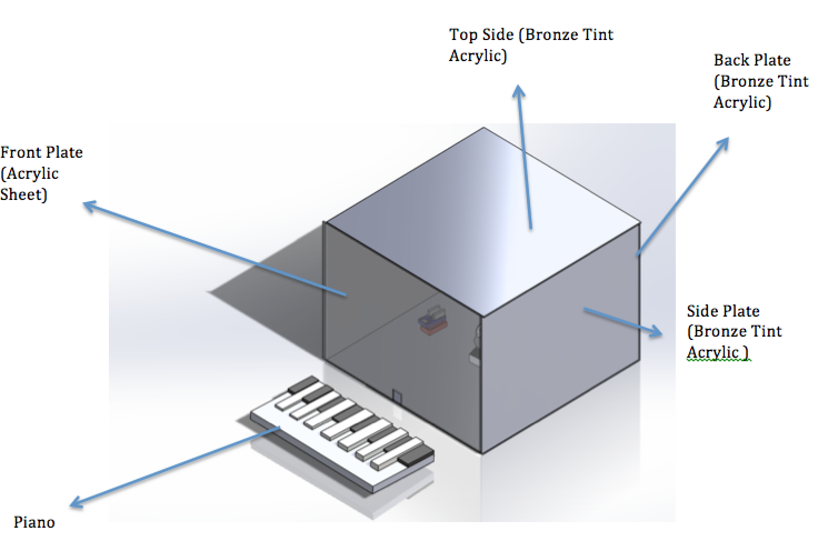

Figure 12- 3D model of design from the outside

Through decoding the circuit with our arduino, we will be able to sequence the lights as prefered based on the deducted sound of the surrounding and the chosen piano keys. Figure 13 displays the inside of our design.

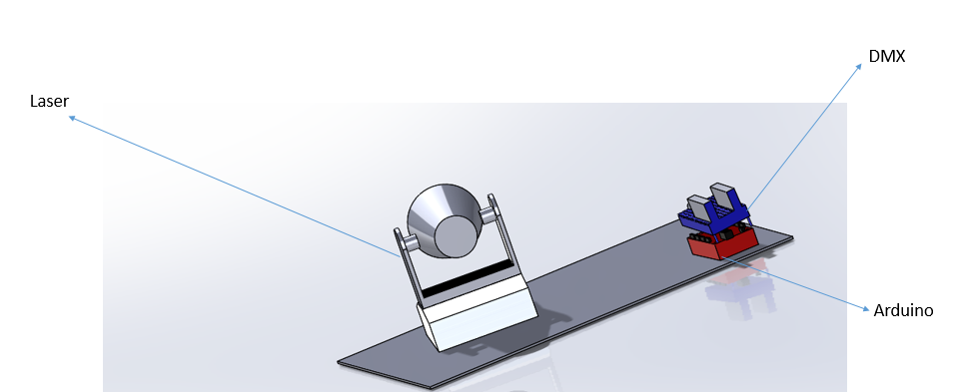

Figure 13- 3D model of the design from the inside

The things that have to be inside are dmx shield, arduino, and laser. Also, the piano will be connected to the dmx shield from the outside by a midi wire. Piano will be connected to the dmx shield from the front plate.

### **5.2.3 Drawings**

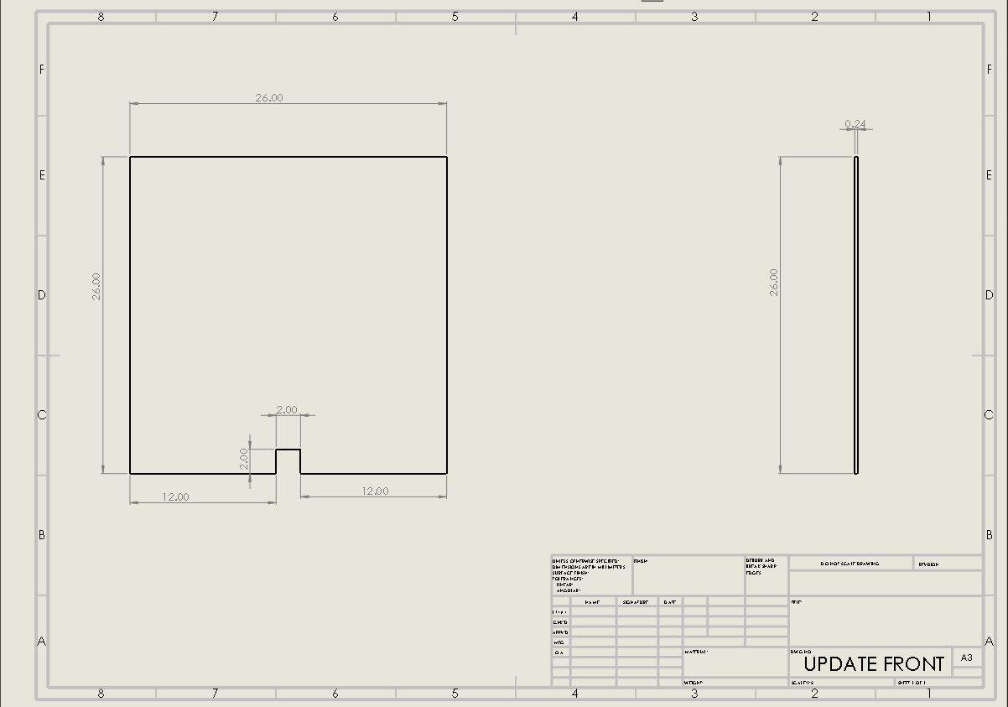

Figure 17 - Front Plate

Figure 17 is basically the front part its 26 x 26 in. Upon talking with Dr.Willy in ME476C, we decided to choose 26x26 in, because we need our box to be good enough not that big and not that small. Also, we wanted the shapes to be projected on the back side. Otherwise, the front and back plates have the same dimensions. Also, there is a hole on the front side because of the wires. The dimension of the hole is 2x2 in. The thickness for the front plate is 0.24 in. The material we are using for the front plate is “Acrylic Sheet”.

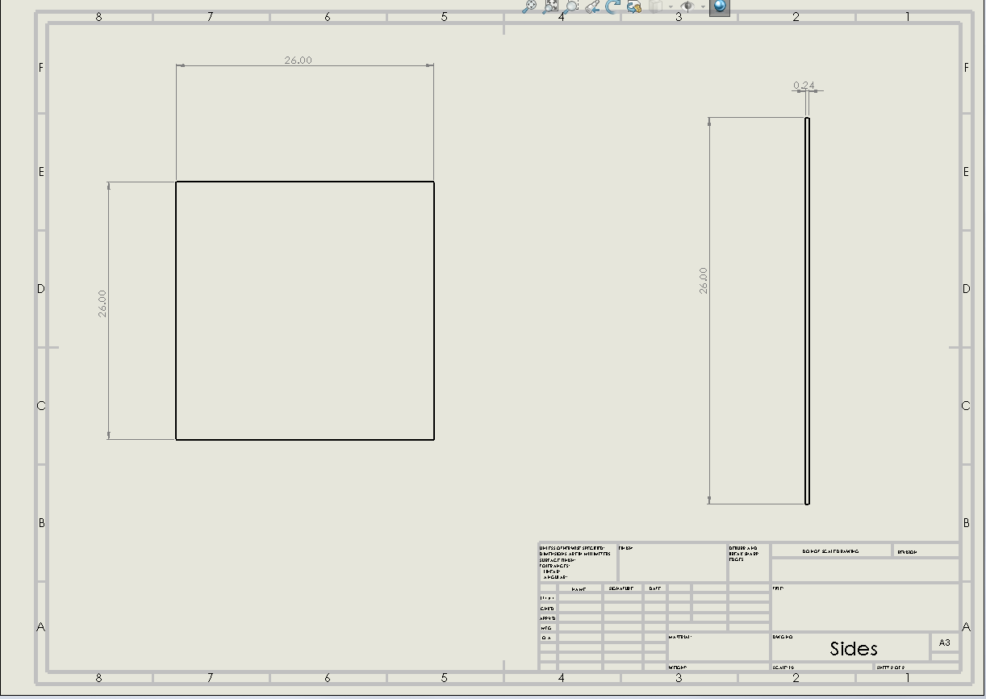

Figure 18- Side Plate

Figure 18 shows the side. Sides have the same dimensions. It’s made from “Bronze Tint Acrylic”. The reason why I chose this is because its light to carry, portable, and flexible. Dimensions are 26x26 in. Why I chose 26x26 in is because I need the box to be a little a bit big inside to let kids see what happens inside (process) clearly, and I need a distance between (Arduino and LED light). The thickness for the side plates is 0.24 in. The side plates are attached with the top plate only because they have brackets. The brackets are glued on the top plate and we slided the sides in the brackets. From that the brackets are holding the side plates.

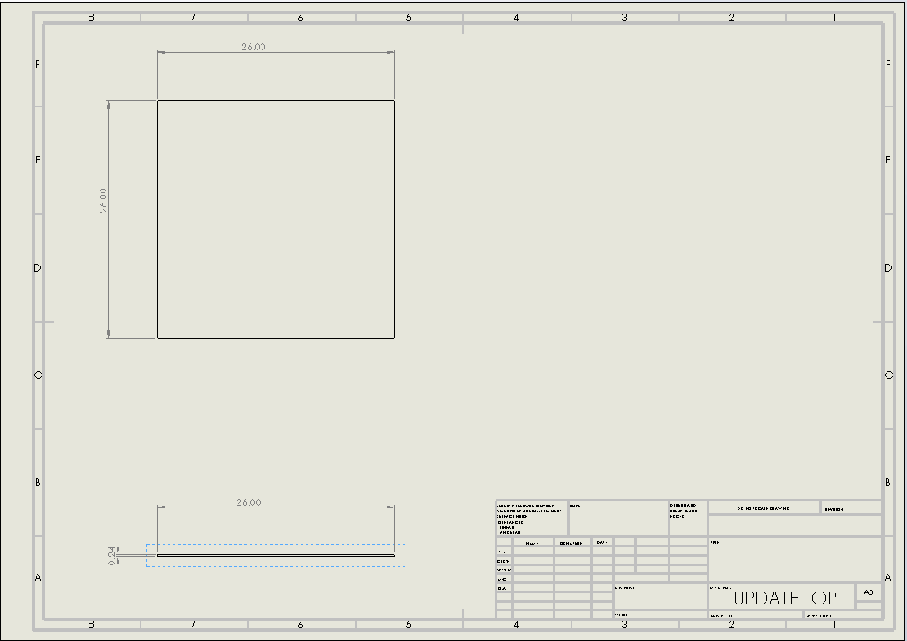

Figure 19 - Top Plate

Figure 19 shows the top side. It’s made from “Bronze Tint Acrylic”. The reason why there is a top plate is to protect the kids from the light rays. Also, to make the projection clear, and the inside should be dark to let the kids see what happens inside the box clearly. The thickness for the top plate is 0.24 in. On this plate we glowed two brackets on each corner to hold the sides, back, and front.

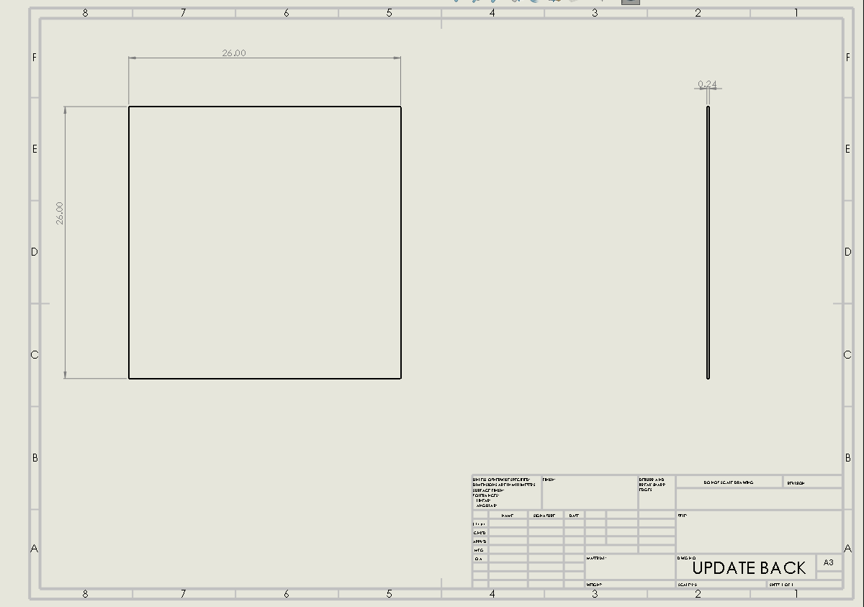

Figure 20 - Back Plate

Figure 20 shows the back plate. It’s made from “Bronze Tint Acrylic”. The reason why there is a back plate is to project shapes on the back. We attached a white sheet on the back plate in order to highlight the shapes. The thickness for the top plate is 0.24 in. This plate is attached with the top plate by using brackets.

Figures 21, 22, and 23 shows three different geometric shapes (circle, hexagon, and a triangle) that are added on each of the three servo motor wings. Each are measured at 1.6 in in diameter. Rotating with the rotational signal of the servo motor and are controlled by the sound coming from the piano keys. The servo motor will be rotating at 0 to 180 degrees and going back.

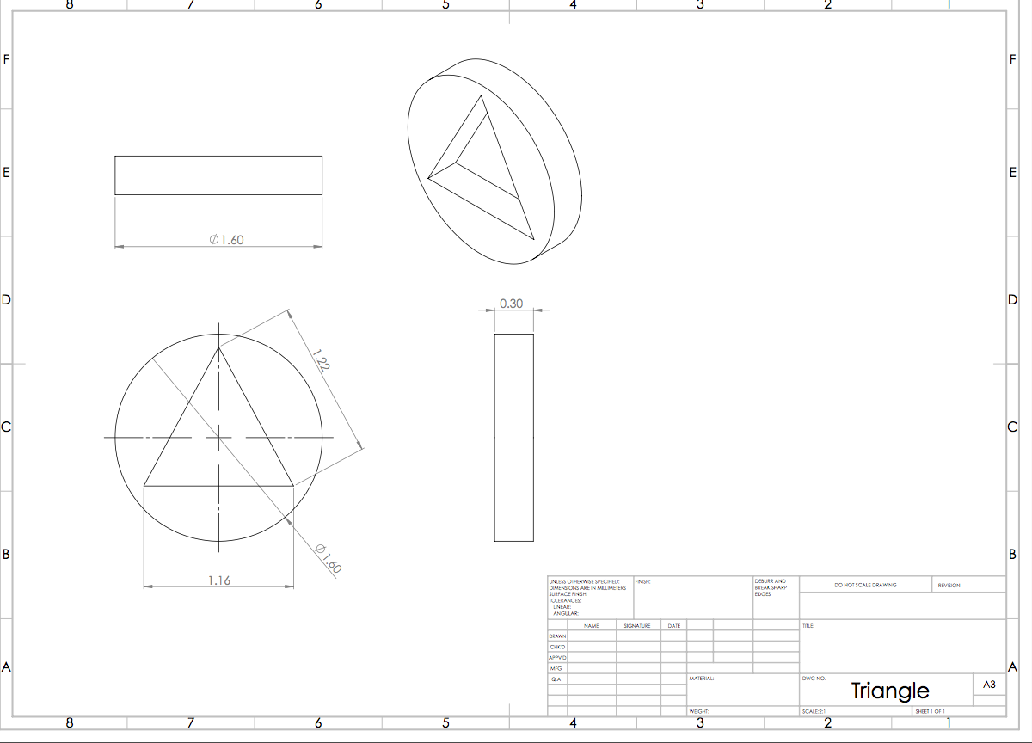

*Figure 21- Triangle*

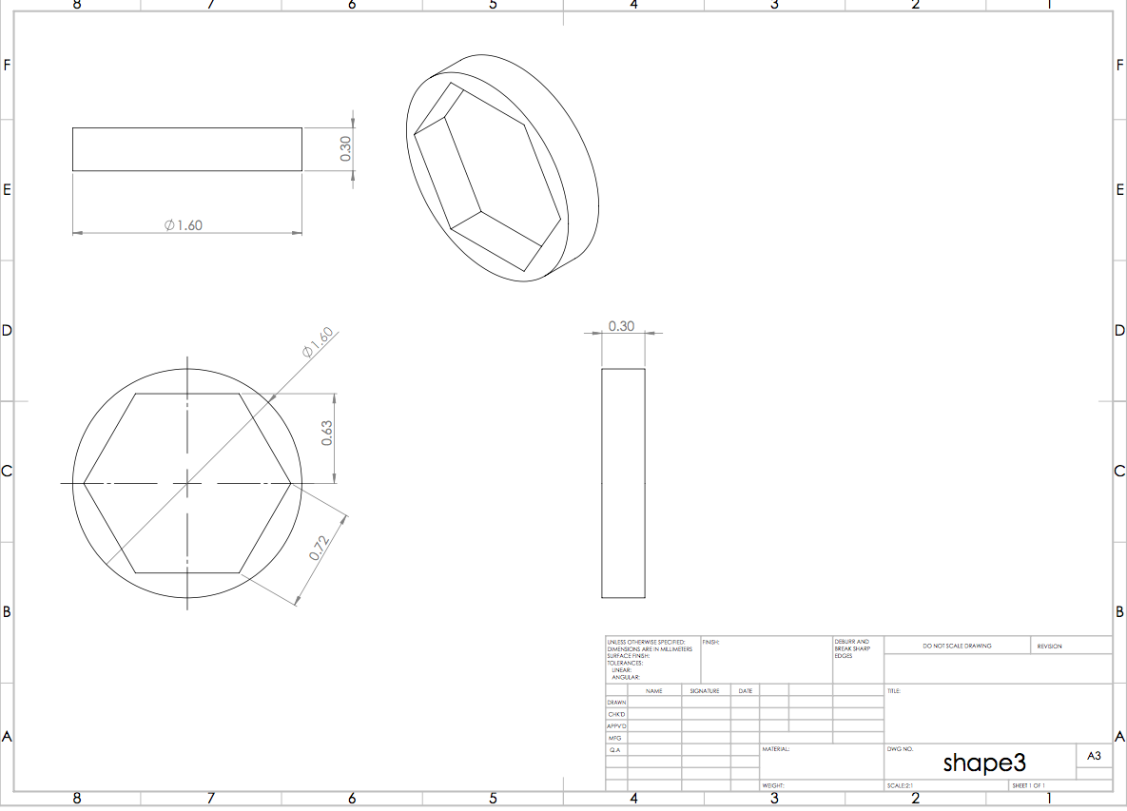

*Figure 22- Hexagon*

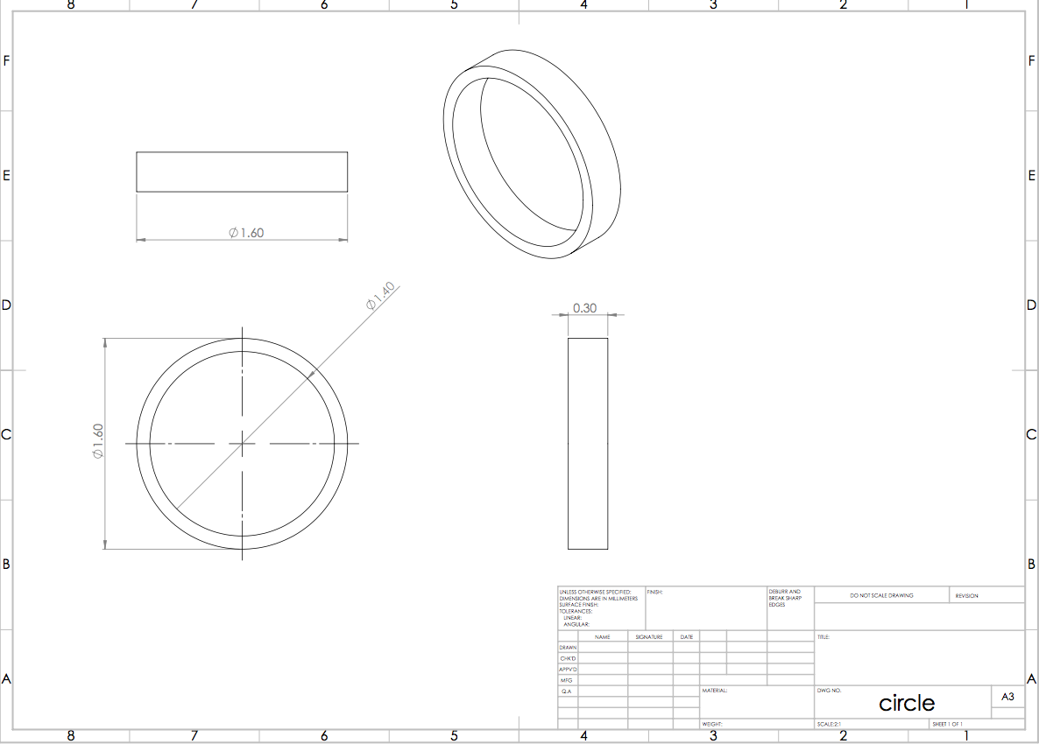

*Figure 23- Circle*

### **5.2.4 Arduino Codes**

Using a redboard for this project is essential, where programming needs to uploaded for this project to do some certain actions and most importantly is for the microphone sound sensor to detect the sound emitted by the musical instrument. As shown in Appendix B, the codes enables the sound sensor to detect any sound nearby, and will then print out a reading. Depending on this reading value, the LED lights will light up. This code may be updated in the future if any other additional actions or components have been implemented into the design. What the future code will have is a program that will control an LED using the attached arduino board. This will be connected in order to be controlled by LED lights.

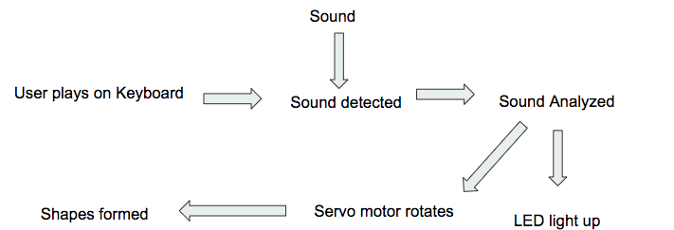

Figure 24- Flowchart of how the code works.

# **6 PROPOSED DESIGN – First Semester**

This section provides the component selection which will be provided in the bill of material (BOM) table. The selection of the parts and components is important where the building this project efficiently is a priority for this team. This section consists of the BOM and the schedule for future tasks.

**BOM**:

This is the BOM that shows the things that we have purchased, we brought the piano because it the interactive part of the project to make the project work, we had to buy the Arduino so we can use it to put codes so it can perform multiple actions, then we had to purchase the sound sensor so it can collect the data from the piano. We had to get the LED so we can indicates the certain frequency from the piano at the end we had to get a laser to visual the part of the design.

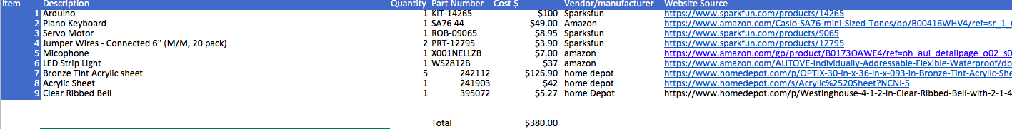

*Figure 25- BOM*

**Schedule**:

Since the last presentation we had 4 things to finish up before the end of the spring semester the final report and the final CAD also we have to finish up developing the website uploading the last presentation, and the report. After the we’re going to start ahead with summer things so we can be up to date also from what we can see we’re moving so fast that from now we already finished things that we had it scheduled for the summer. We can say that we’re on the correct track.

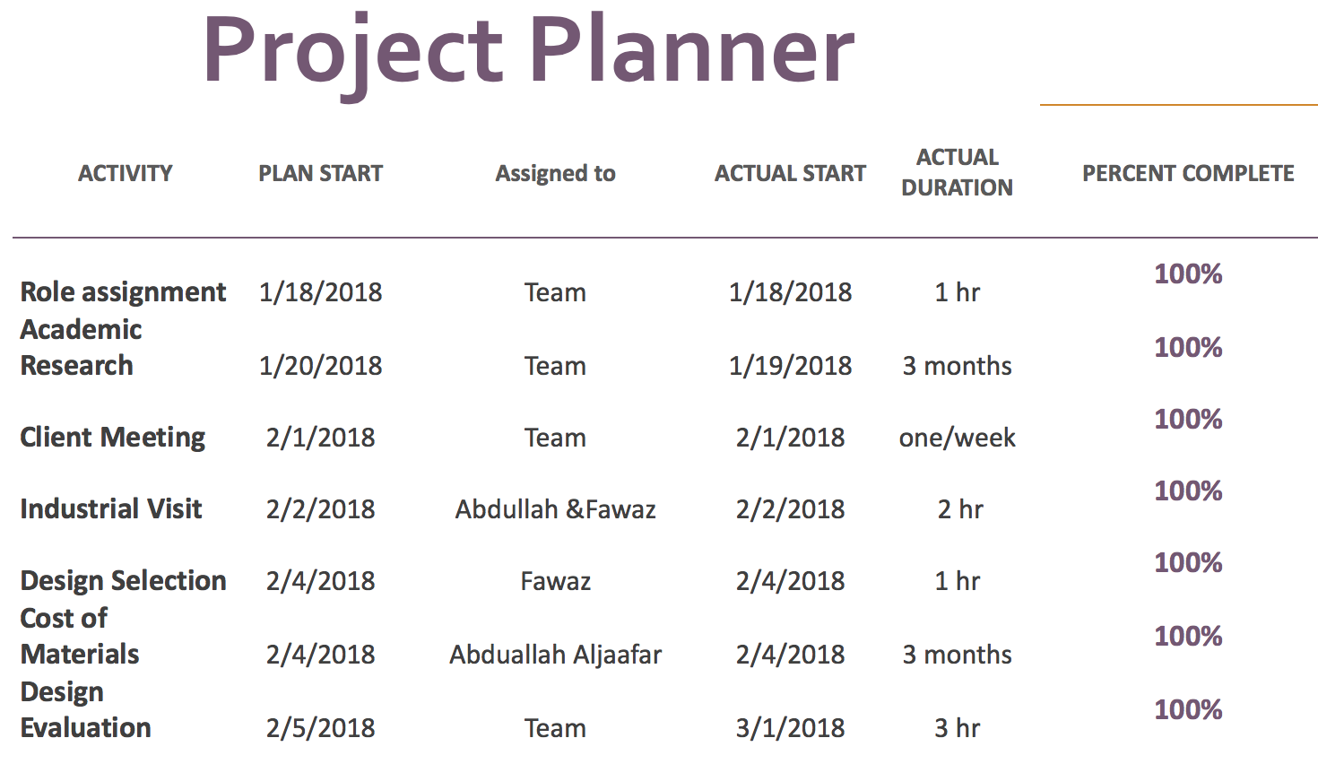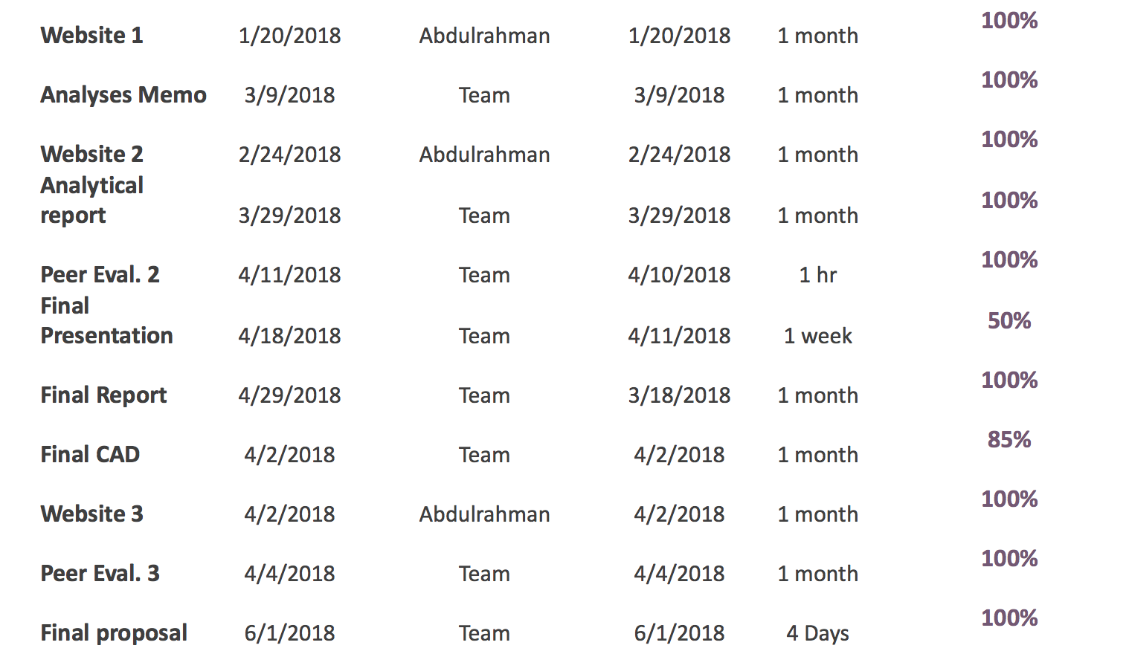

Figure 26- Spring 2018 semester schedule showing future tasks.

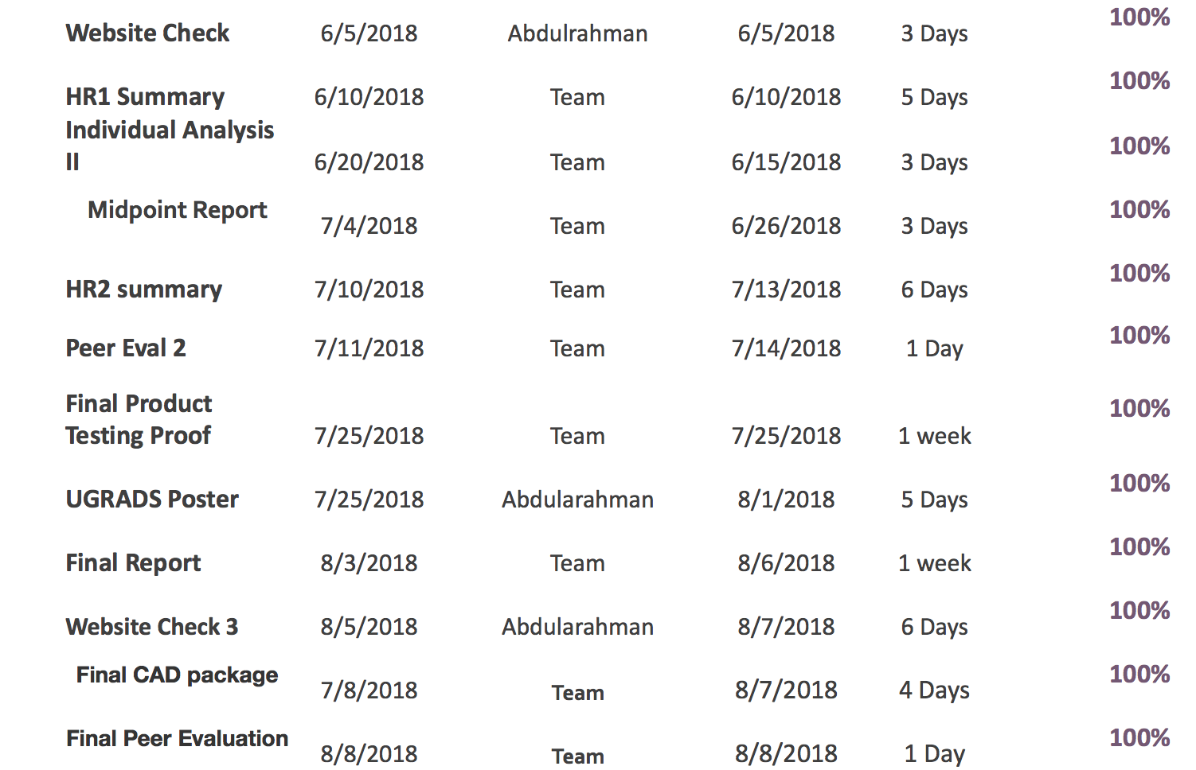Figure 27- Summer 2018 schedule showing future uncompleted tasks.

# **7 IMPLEMENTATION – Second Semester**

The implementation of the parts needed to successfully execute the functionality of the project is essential. This sections will provide a detailed overview of the manufacturing process, detailing the material used, and how the container is being built. The other thing this section will provide is the setup of the arduino circuit that is connected to the LED light. The final design of the project was accomplished after many changes that were made throughout the semester, where these changes were made to benefit the requirements of the project.

## **7.1 Manufacturing**

Building the box has different plates. The plates are back, two sides, top, base, and front, they are made from “Bronze Tint Acrylic” except for the front plate. The reason behind why we chose this material is because it is light, and easy to carry. Also, it is not that expensive, referring to BOM in Figure 20. We putted black sheets on the two sides, and top because we do not want any light rays to enter the box. Wherase if we chose a black colored surface, the projection might be dim. Also, we need to put a white sheet on the back because we need the resolution of the projection on the back plate to be clear. Except the front plate because kids are able to see what happens inside the box, and to protect kids from the light rays. The front plate is made from “Acrylic Sheet”. We made a hole on the bottom of the front plate to allow the wires to connect the piano to the dmx shield. The reason behind why we chose this material is because it is light, and portable. Also, it is cheap, referring to BOM in Figure 23.

Now, the process of how can we build our box based on the plates that I explained in the previous paragraph. We used water glow, we put the glow on the bottom corner of each the sides, back and front and stick it on the base. Then, We glowed the top plate on top view of the back, sides and front plates. This is basically how we built our box.

Following building the box, we connected the piano to the arduino circuit shown in Figure 9 from one side and the LED laser to the other. Thus, taking the chosen piano key into the arduino circuit and delivering a command to the LED laser to display a certain shape. The next steps required us to come up with a specific coding to function the circuit. Through having different sources of search, recommendations, and tutorials from the arduino website [4]. The team managed to code the arduino circuit and apply it as preferred with how the keys functions, as shown in 9.2 Appendix B. The following flow chart explains the beginning of the coding system and how it should be started.

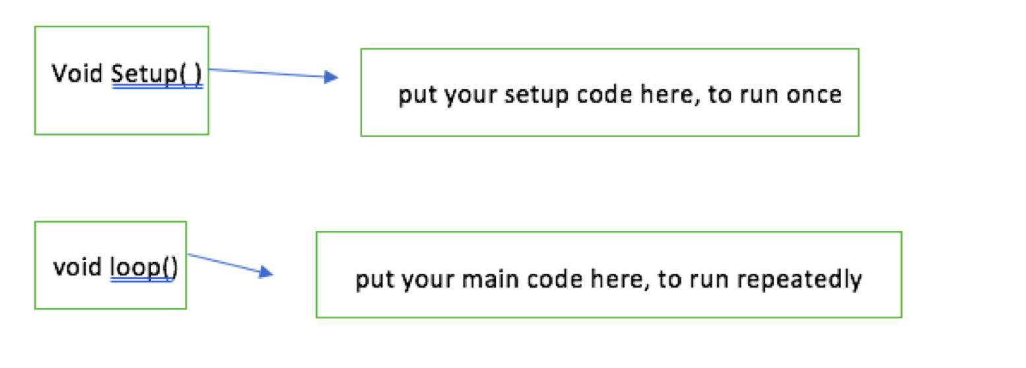

First, starting things with naming different static constant integrals as different colors with each color representing a value for now (piano key). For example, green is equal to zero, yellow is equal to 1, and red is equal to 2. Calling the list of the light pins through commanding the integral as int lights[3]; with having a list of 3. The pin of the indicator and state of pin are following the same procedure, but only with changing between int with either inductor or state. Next, creating a new lighting system through setting all lights to output and inductor to input.

The codes available in Appendix B, are uploaded to the arduino, and from the arduino we connected wires from the arduino to the sound sensor where we needed the analog pin (A0) to read the incoming sound. In addition to these wires, three wires are connected to the LED, a wire connected to the 5V input, a wire connected to the ground and a wire connected to the digital pin so that the LED could be controlled through the codes.

## **7.2 Design Changes**

The team found out a couple of issues in regards to the final design after finishing from ME476C. Some changes were based on the physical modeling of the design like making the plates thin rather than thick, adding brackets on the edges to assemble the plates together, changing the container from 36x36in to 26x26in, and the top plate was dimensioned 36x36 in and was changed into 26x26 in. As for the circuit, we added two header (male and female) to attach both the piano from one side and the LED laser lights to another side. The material of the bracket is PLA (polylactic acid) bioplastic. The dimensions are 1.5x0.75 in.

These dimensions were chosen because it has to be small to hold the parts and assemble them together. The thickness for the bracket is 0.24 in. The idea of the implementation of the brackets was changed and were removed from the plates , where when the team tried assembling the plates together using the brackets, the container was unstable and may collapse which makes it sensitive to any tough. This was an issue because of the location that the container will be set is in an exhibition that will be surrounded by children thus increasing the risk of the container collapsing. With this in mind, the acrylic plates were glued together by applying glue on the sides of the plates. This design change makes it more stable and reduces assembly time, where to make it more stable, and addition of one acrylic plate to be the base of the container was an essential change that was made.

Another design change that was made was the removal of the DMX where the team went with the sound sensor. The DMX and the sound sensor both accomplishes the project’s goal, but with the use of the sound sensor, there will be lesser wires to be attached meaning less hassle to assemble. The use of the DMX is new to the team, meaning the removal of it lowers the risk of having the system malfunctioning.

Changing from an DMX controlled LED projector to an RGB LED strip was a major change, where the projections of lights is the whole purpose behind the project. Using the DMX controlled LED projector uses several other components that needs to be implemented onto the circuit, meaning codes and research for each of these components are need, and o top of that, the power need is higher to power up the projector. On the other hand, the RGB LED strip is flexible, and it is light weight thus accommodating the weight requirements given to the team by the clients. The RGB LED strip is easier to program [5] ,and only uses a 9V battery that could be attached to the Arduino. It also uses lesser wires thus easier to assemble if any of the wires ever got detached.

The most noticeable design change is using the acrylic container instead of the tent, where the team thinks that for the LED projection, the 26inx26inx26in container will have enough area for it to project on. In terms of time of assembly, the acrylic container which uses the sliding mechanism is easier to assemble that the tent, where the tent is larger in size and has many other components needed to setup the tent. The benefits of using acrylic sheets [6] helped in our decision making process.

**8 Testing**

Table 2 shows our engineering requirements throughout the project. Based on our operation procedures, they are broken down into 8 including the cost. Also, they were all changed in regards to the project’s preferences and fits. Before building the host box, we made sure that each of the six flat plates do not exceed the weight of 22.46 all combined. The Wonder Factory has set up a limit of weight and upon meeting with the client we expressed a number of flat plates and which ones are we advised to use. Considering The Wonder Factory’s intentions of adding the project to their collection, we made sure that the materials from the plates, piano, circuit, and LED lights are all long lasting and are in a better quality to make sure that they are good to be kept in any condition inside the factory. The circuit power and handling should not exceed 12 volts otherwise it will get exploded. In one of our trials, the LED lights were more than 12 volts that it caused the circuit to be burnt and then it started to work again but in a very weird way, moreover, it was acting up in terms of switching the sound sensor on and off without even touching it. Safety is another aspect and requirement that we were highly advised to be attention to considering the fact that The Wonder Factory visitors are mostly kids. Therefore, we made sure that the box is safe to be around without letting the lights get out of it hurting their eyes. The front plate was covered with extra layers of white sheets not only to serve as a good reflector to the lights but also to cover the lights from coming through the box. From the sides, the LED were hosted inside a glass core that we painted entirely in black. As for the aesthetic appeal, we made sure that the device is attractive enough to bring the kids over to it and try it. We first played with the piano and did set up a certain tone that the piano keys would play once hit. Earlier, the sound were a bit normal, but later we used the piano buttons to change the tone into a more funny ones or spooky ones. The colors of the shapes would change every half a second thus creating a beautiful visual imagery with geometric shapes and sound at the same time. About the power requirement, the device in all its part from the piano, circuit components, and LED lights should not go over 500 watts as calculated and discussed by The Wonder Factory’s manual. We then calculated every component and added their power value up back in capstone 1, which was way below 500 watts (around 90 to 110 watts approximately). Finally, the cost must not be more than 400$. Our bought items including the circuit small components was estimated at $380.

**9 CONCLUSIONS**

In conclusion, this section provides a detailed overview of the progress made by the team towards accomplishing the project. This section will also state whether the purpose of the project was met and how the team worked with the team charter that was made at the beginning of the first semester. In addition, improvement of the team’s performance is essential for the team to accomplish the project and produce efficient results at the end that satisfies both the client and the team members.

**9.1 Contrib. to Project Success**

This section will be covering the team’s performance, contributions, and areas of weakness as experienced while taking both senior design classes. Going back earlier, the team choose between a variety of projects and rank them down based on personal preferences from, top being most preferred. All five of us had The Wonder Factory as his top choice and from then we got to know each other and exchange ideas. Next, we were asked to come up with 50 ideas and present them to our client. The 50 ideas got broken down into three final ideas, and finally into one. Throughout ME476C, we searched, sketched, presented, and wrote about our chosen idea in a thorough manner. This assignment will help us realize what went right and what needs to be fixed while approaching our finalized steps of the project and ME486C assignments. The senior design classes are major keys that will push us further into planning ideas and applying them into our work field as engineers.

The ground rules and coping strategies stated in the team charter were followed in a mature and respectful way possible. In addition, the team were to meet twice or three times a week to go over what should be presented to the client or instructor in a weekly manner in order to be ahead of the asked for time. The mentioned ground rules were not broken at all as each member respected his place in a senior design class meaning that he is in the highest design class and it is not to be taken softly or with weakness.Pleasing the clients was one of the rules that the team made sure to put into perspective, and managing time was a skill that the clients were happy with. The team made sure to perform at the highest level to complete tasks on time. The number of ideas and improvements that each member came up with during our meetings was countless. The team coped within its members finely by listening to different ideas and disagreements in a mature way. When we were asked to create the team charter, one portion asked for what is the possibility of a high pathetical problem between the team and what would you do to solve it, gladly, the team never have ever experienced such an occurrence and instead the team is fully committed to this project and is kept motivating each team member to act professional and not stop participating. There were a lot of project performances that were most positive while approaching ME476C. To name a few, time management was a major performance skill that each member adapted. There was no time to waste while having a meeting with the clients or instructor as the team was informed with alerts and texts in the group text message to come at a certain time and organize their schedule of classes or daily routine to-do list. Also, work quality was another major performance skills that functioned positively. Before each assignment, the time set a schedule and broke down who does what in advance by weeks. Thus, allowing us to check with both the instructor and TA about the quality of our work before presenting it to our client. This helped us to be aware of any mistakes and fixing them before the deadline is due.

The team became acclimatized to prepare an outline of ideas or questions whenever approaching the instructor and how could the team project’s level of quality benefit from it. This is a methodology that some of us gained after being students in three EGR classes and teaming up with other engineering major students. It personally helped us to come up with effective conclusions and branching out what comes to mind at once into what should be spoken of or written down on paper. Practicing not receiving the desired grade and working on the comments of why has helped the team to improve beyond expectations.

During the span of 8 months from January to August of 2018, the team has experienced many detours and had to take different routes than planned. First, the idea that was finalized as our chosen one from the delivered fifties was modified in many ways. Upon meeting with our instructor, he has introduced as do different software to use in order to enhance our main project device (Arduino). He gave us our first step into launching codes and practicing how to use them into applying out the desired results. From then, we managed to take the wheel and move forward to reform our idea based on the physical devices that can be viewed by seeing, and other idea aspects that were coded and created using a computer and notes taking. The team stumbled upon a problem while trying to figure out how to use the circuit of the Arduino redboard. Considering that we have taken only one circuit class, we were not sure about the quality of the work, but we searched for ways to function a circuit on the redboard. Discovering many videos on YouTube about how to get a head start and reading the redboard manual guide, the team was able to start, restart, and apply changes to the redboard. Of course, before getting the to-go-green light, the team had to check with the instructor and see how good of a circuit design it is. Next, the team had a few issues with coding the Arduino. The team met with cline library IT whom told us about the codes and what can you do to command it. The instructor in his turn guided us to different websites and textbook manuals that came in handy. Upon our first test try, the Arduino did not function according to plan, but through different test tries and learning from the errors yielded, we were able to come up with the result needed. During our final presentation, we demonstrated the redboard and how the LED lights lit up when the sensor detected the sound coming from an iPhone that was playing a song. The instructor gave us his feedback immediately of how good it functioned. Towards the end of the class, the team managed to solve out any problems that might occur and work hard to find a solution from the instructor or through searching the web

**9.2 Opport. For Improvement**

Improving performances when working with a project is a challenging aspect and tool, but what is more challenging is taking an organizational action and working a way out to use it as a solution to upgrade a performance. Specifically, the team worked many days to finish a report on time and made sure to check it more than once before submitting it. When not knowing how to handle a certain step of the design, the taken action is always, first and foremost, talked about between the teammates and if we could not find a solution, we would talk about it with our instructor. Specifically, improving our understanding of what is given to us and handling it professionally without giving up on how to work it or relate it to our final project design. If noticing any weakness regarding a team member during a presentation or assignment, we would discuss how to efficiently he can use out his weakness into strengths. Also, try hard to stay focused and on track when approaching the purpose and goals of the project by not only hope for what to achieve but actually working on achieving it by taking some of the teammate’s time aside from his classes and doing researches or demonstration outside the class. More importantly, putting on considerations different point of views and discuss the differences with remembering that facts can be wrong, but opinions re just different. As always, listening is an action of improvement and a very needed one in order to succeed as a group. Making sure that all viewpoints are heard and also pointing out that some people might be locked in to their own opinions and thoughts. Thus, not having the timber to consider some merits of their surroundings and what they think. Therefore, listening and accepting disagreements maturely as a huge improvement to any performance

There were a plenty of techniques that the team has learned throughout this project. For example, respecting different views in regard to someone’s own view and working hard on flaws as an upcoming engineers were a delivery gotten from the project. Also, working on both the Arduino codes and redboard circuit did expand on our technical knowledge of engineering. The team have tackled both setting up circuits and creating computer codes in one class for each through our degree seeking classes. Now, we have set a foot on how to build up an idea mechanically and electrically all through computer codes and physical build ups. Searching and reading about different laser types has enlightened the team about a variety of lights and how they break into conducting a graphically mesmerizing show to the eyes.

**10 REFERENCES**

[1] Discoveryplace.org. (2018). *History | Discovery Place*. [online] Available at:

<https://www.discoveryplace.org/about/history>.

[2] Discoverykidslv.org. (2018). *Ongoing Exhibits | DISCOVERY Children's Museum*. [online]

Available at: <https://www.discoverykidslv.org/category/exhibits/ongoing-exhibits/>.

[3] Thinkery. (2018). *About - Thinkery*. [online] Available at: <https://thinkeryaustin.org/about/>.

[4] “DMX Explained; DMX512 and RS-485 Protocol Detail for Lighting Applications,” *Recent Posts*, 24-Aug-2017. [Online]. Available: https://www.element14.com/community/groups/open-source-hardware/blog/2017/08/24/dmx-explained-dmx512-and-rs-485-protocol-detail-for-lighting-applications.

[5] Hansjny, “hansjny/Natural-Nerd,” *GitHub*. [Online]. Available:

[https://github.com/hansjny/Natural-Nerd/blob/master/arduino/soundsread2/sound](https://github.com/hansjny/Natural-Nerd/blob/master/arduino/soundsread2/sound_reactiv)

[_reactiv](https://github.com/hansjny/Natural-Nerd/blob/master/arduino/soundsread2/sound_reactiv)e.ino.

[6] PMMA, A., Action, P., us, A. and us, C. (2018). *Acrylic sheets - PMMA : Benefits -*

*Pmma online*. [online] Pmma online. Available at:

https://pmma-online.eu/benefits/ .

# 

# 

# 

# 

# 

# 

# **11 APPENDICES**

## **11.1** **Appendix A: Designs**

**The pressure energy**

It’s a game the kids will challenge each other .The idea of this design is that we have balls and in front of each ball we have a chair .Under the chairs we have balloons ,so when the kid sit faster the balloon will release the air so the ball will move.

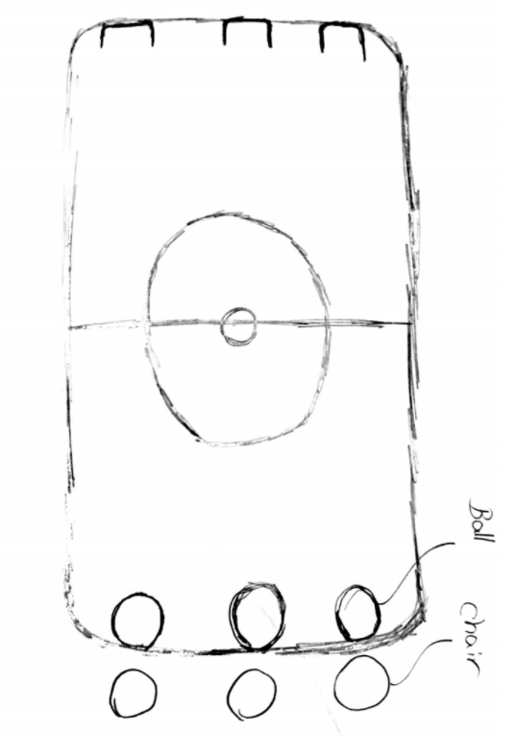

Advantages: Disadvantages:

1-Educational 1-size

2-Enjoyable 2-Expensive

3-easy to use 3-hard to move

4-safety

**The earthquake**

The idea of this design is to show the kids that how the earthquake happens and how its effect on earth.we will have many layers that will be attached to each other.The kids will push a button the layers will separate them.

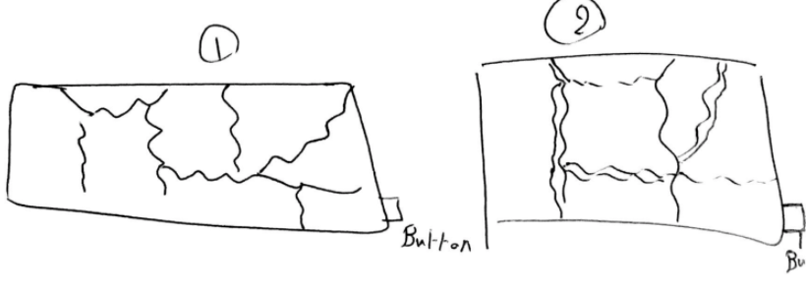

**Advantages: Disadvantages:**

1-inexpensive 1-single user

2-educational 2-boring

3-easy to use 3-time consuming

4-simple to operate

**The race**

We will have many bicycles from 1 to 5 the kids will ride the bicycles.The bicycles will be attached to a pulley and the pulley will be attached to a horse toy that shows a hourses.so when the kid ride the bike faster the pulley will turn faster so the horse will move forward faster.

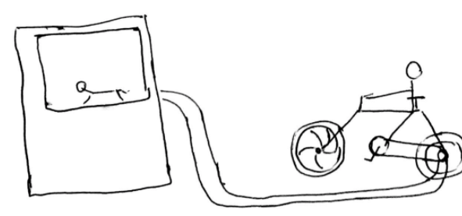

**Advantages:**  **Disadvantages**

1-Educational 1-Size

2-easy to use 2-expensive

3-enjoyable 3-hard to operate

4-multiple users

**The tornado**

This design will show the kids how and from what the tornado begins.they just need to push a button then there is two turbines will work in front of each other. So the turbines will pump the air .

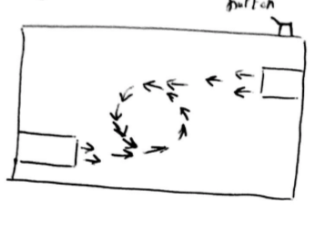

Advantages: Disadvantages:

1-Educational 1-single user

2-easy to use 2-boring

3-easy to operate 3-expensive

4-size

**The fraction spinner**

In this experiment we will have a spinner,steal board and a thermometer.the kids will spin the spinner,the spinner will spin in the steal board and the steal board will be attached to a thermometer we will see the difference in the temperature before and after the spinner.

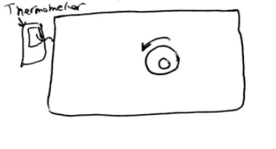

**Advantages:**  **Disadvantages:**

1-easy to use 1-dangerous

2-inexpensive

3-size

4-educational

**11.2**  **Appendix B: Arduino Code (Sound Detection Sensor)**

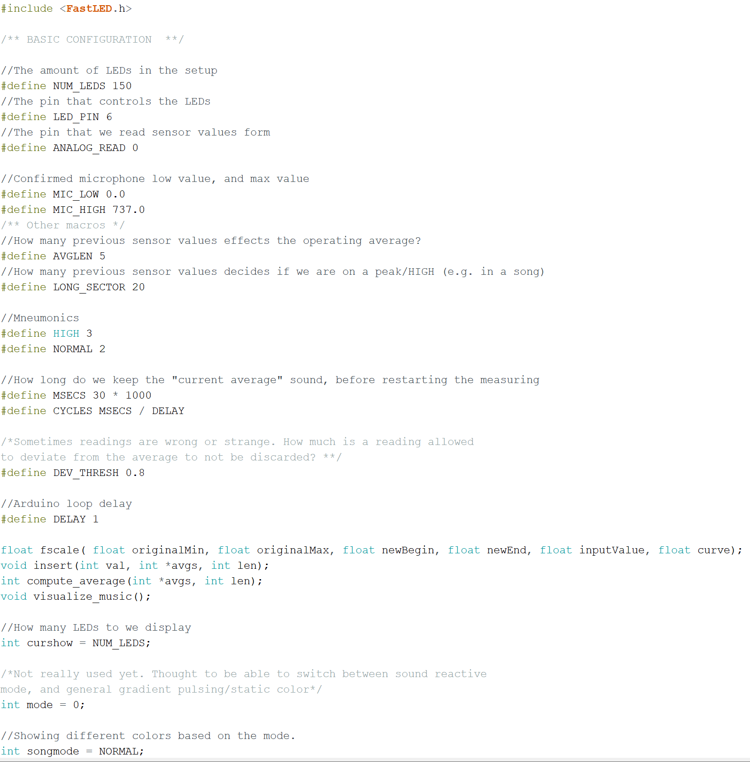

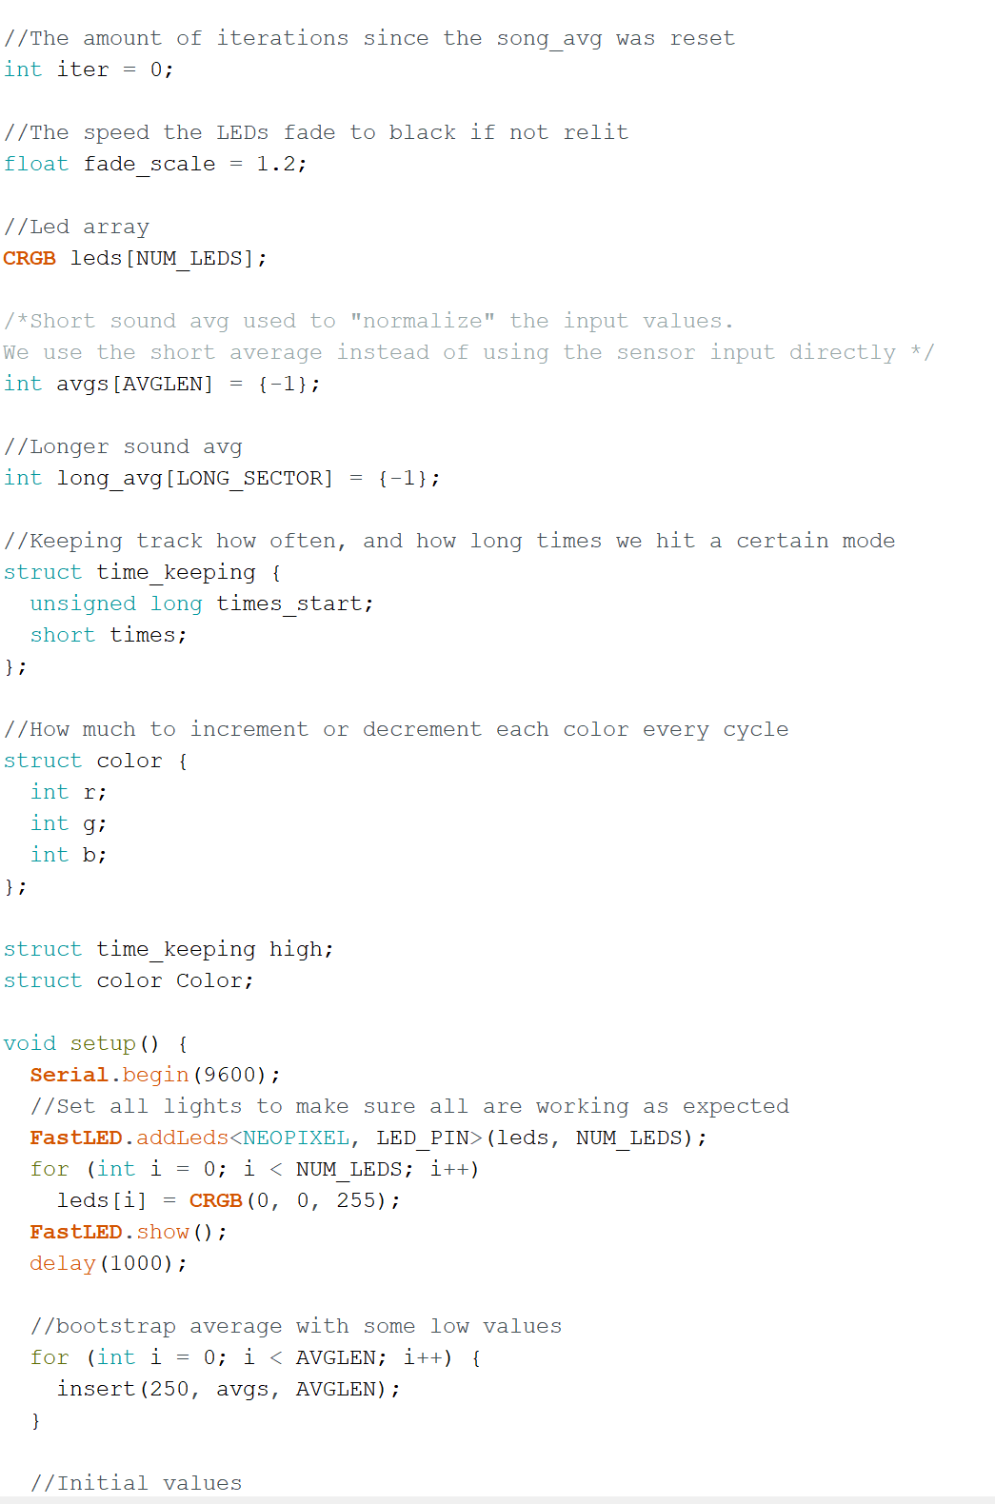

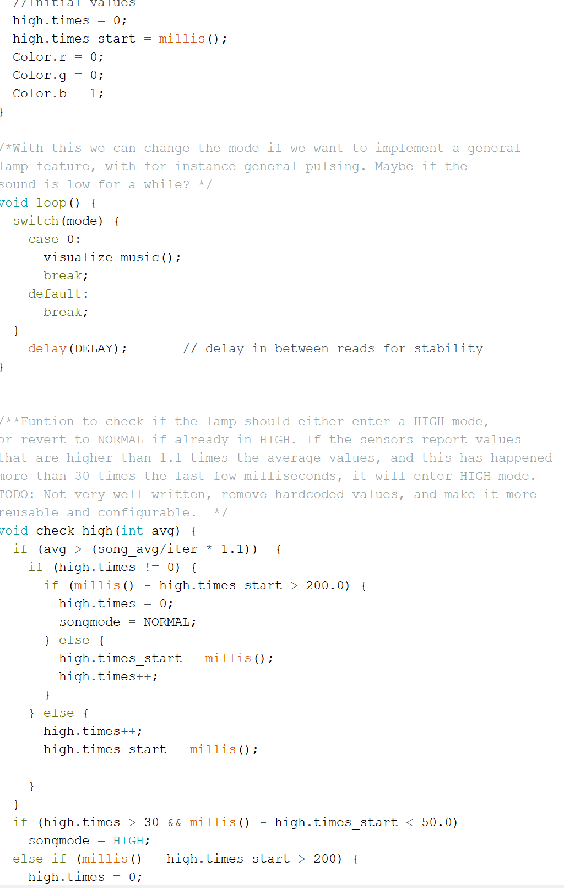

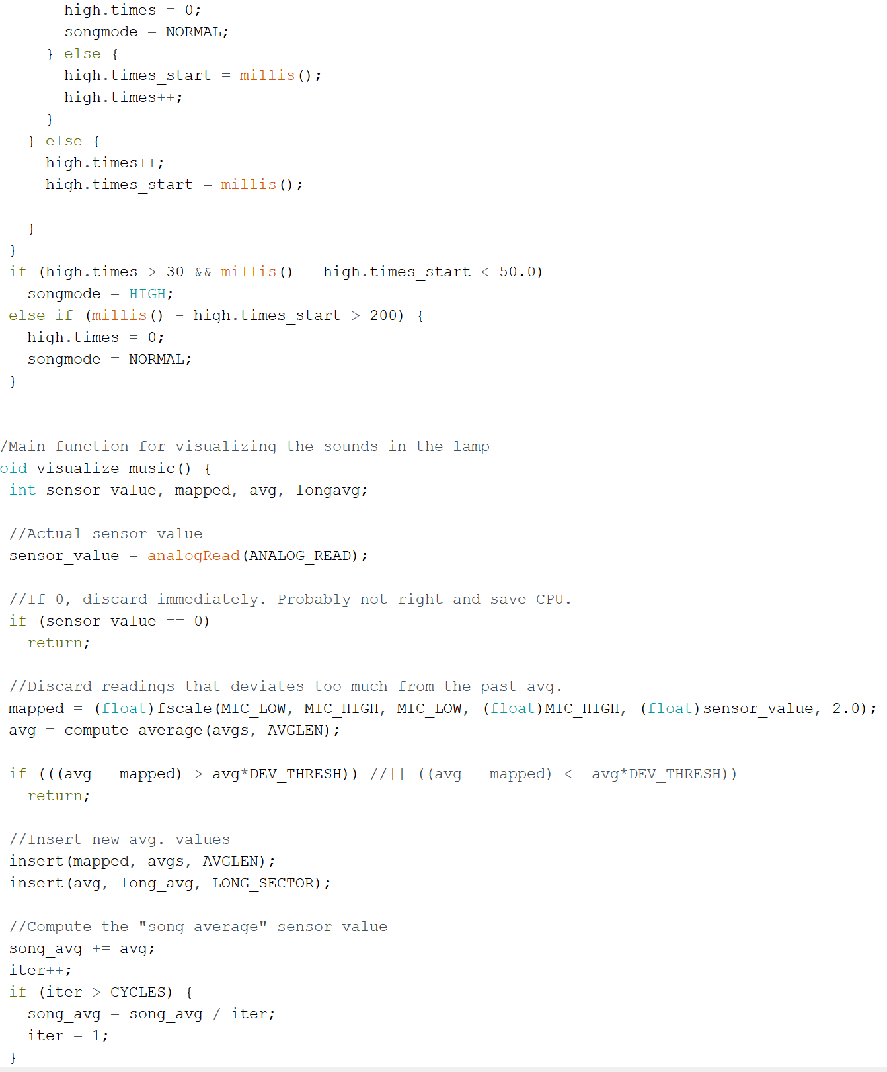

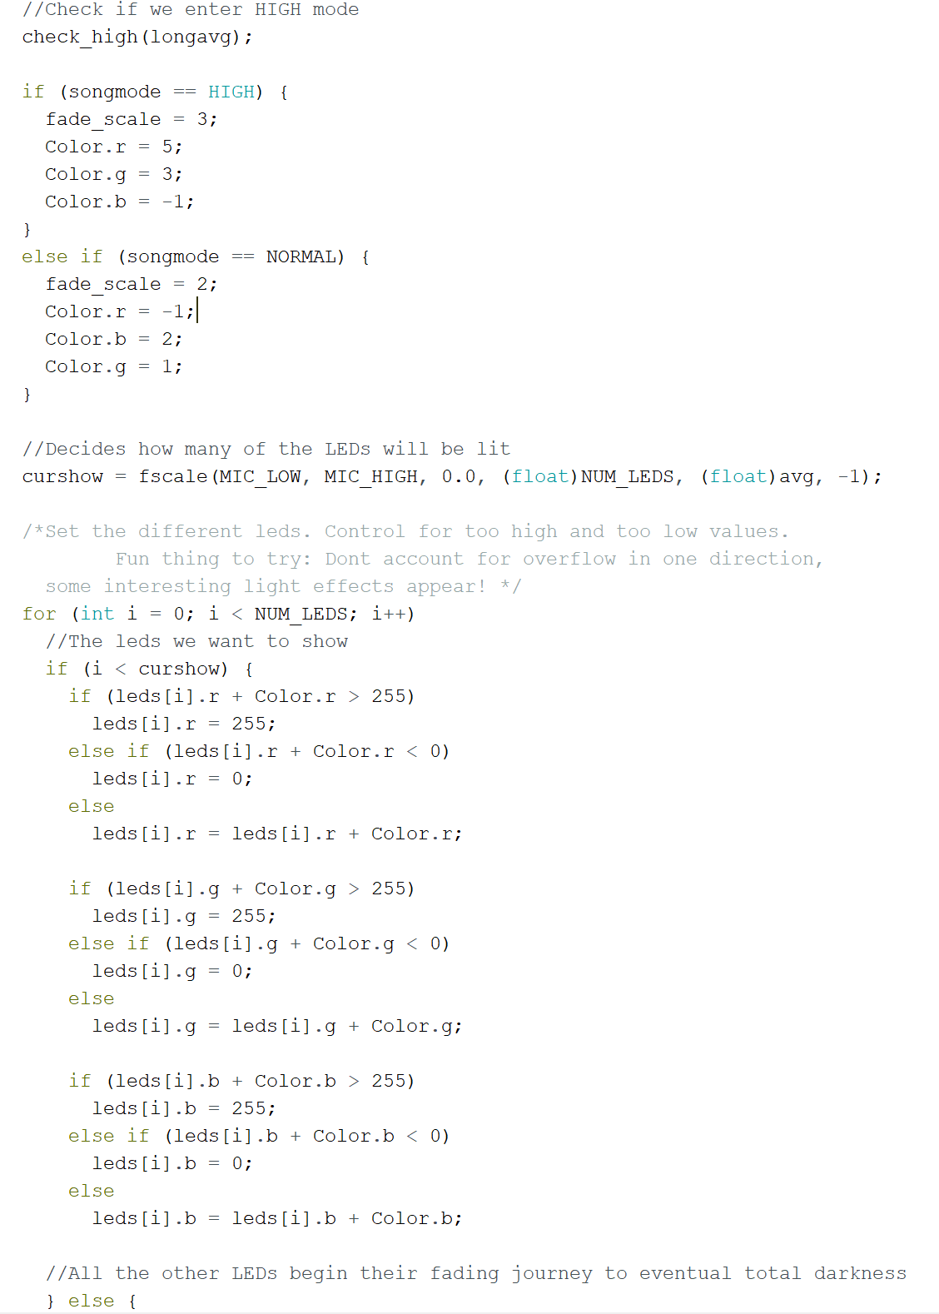

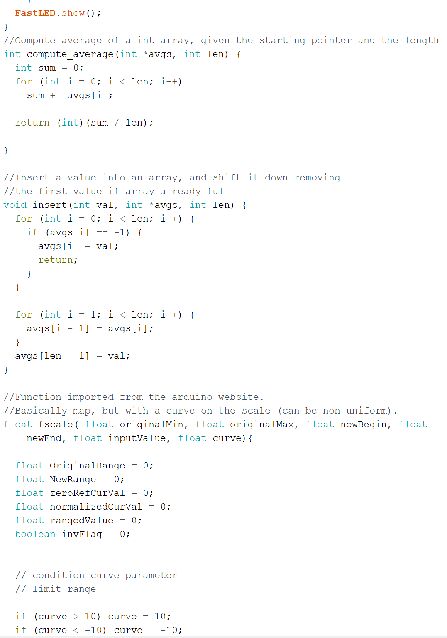

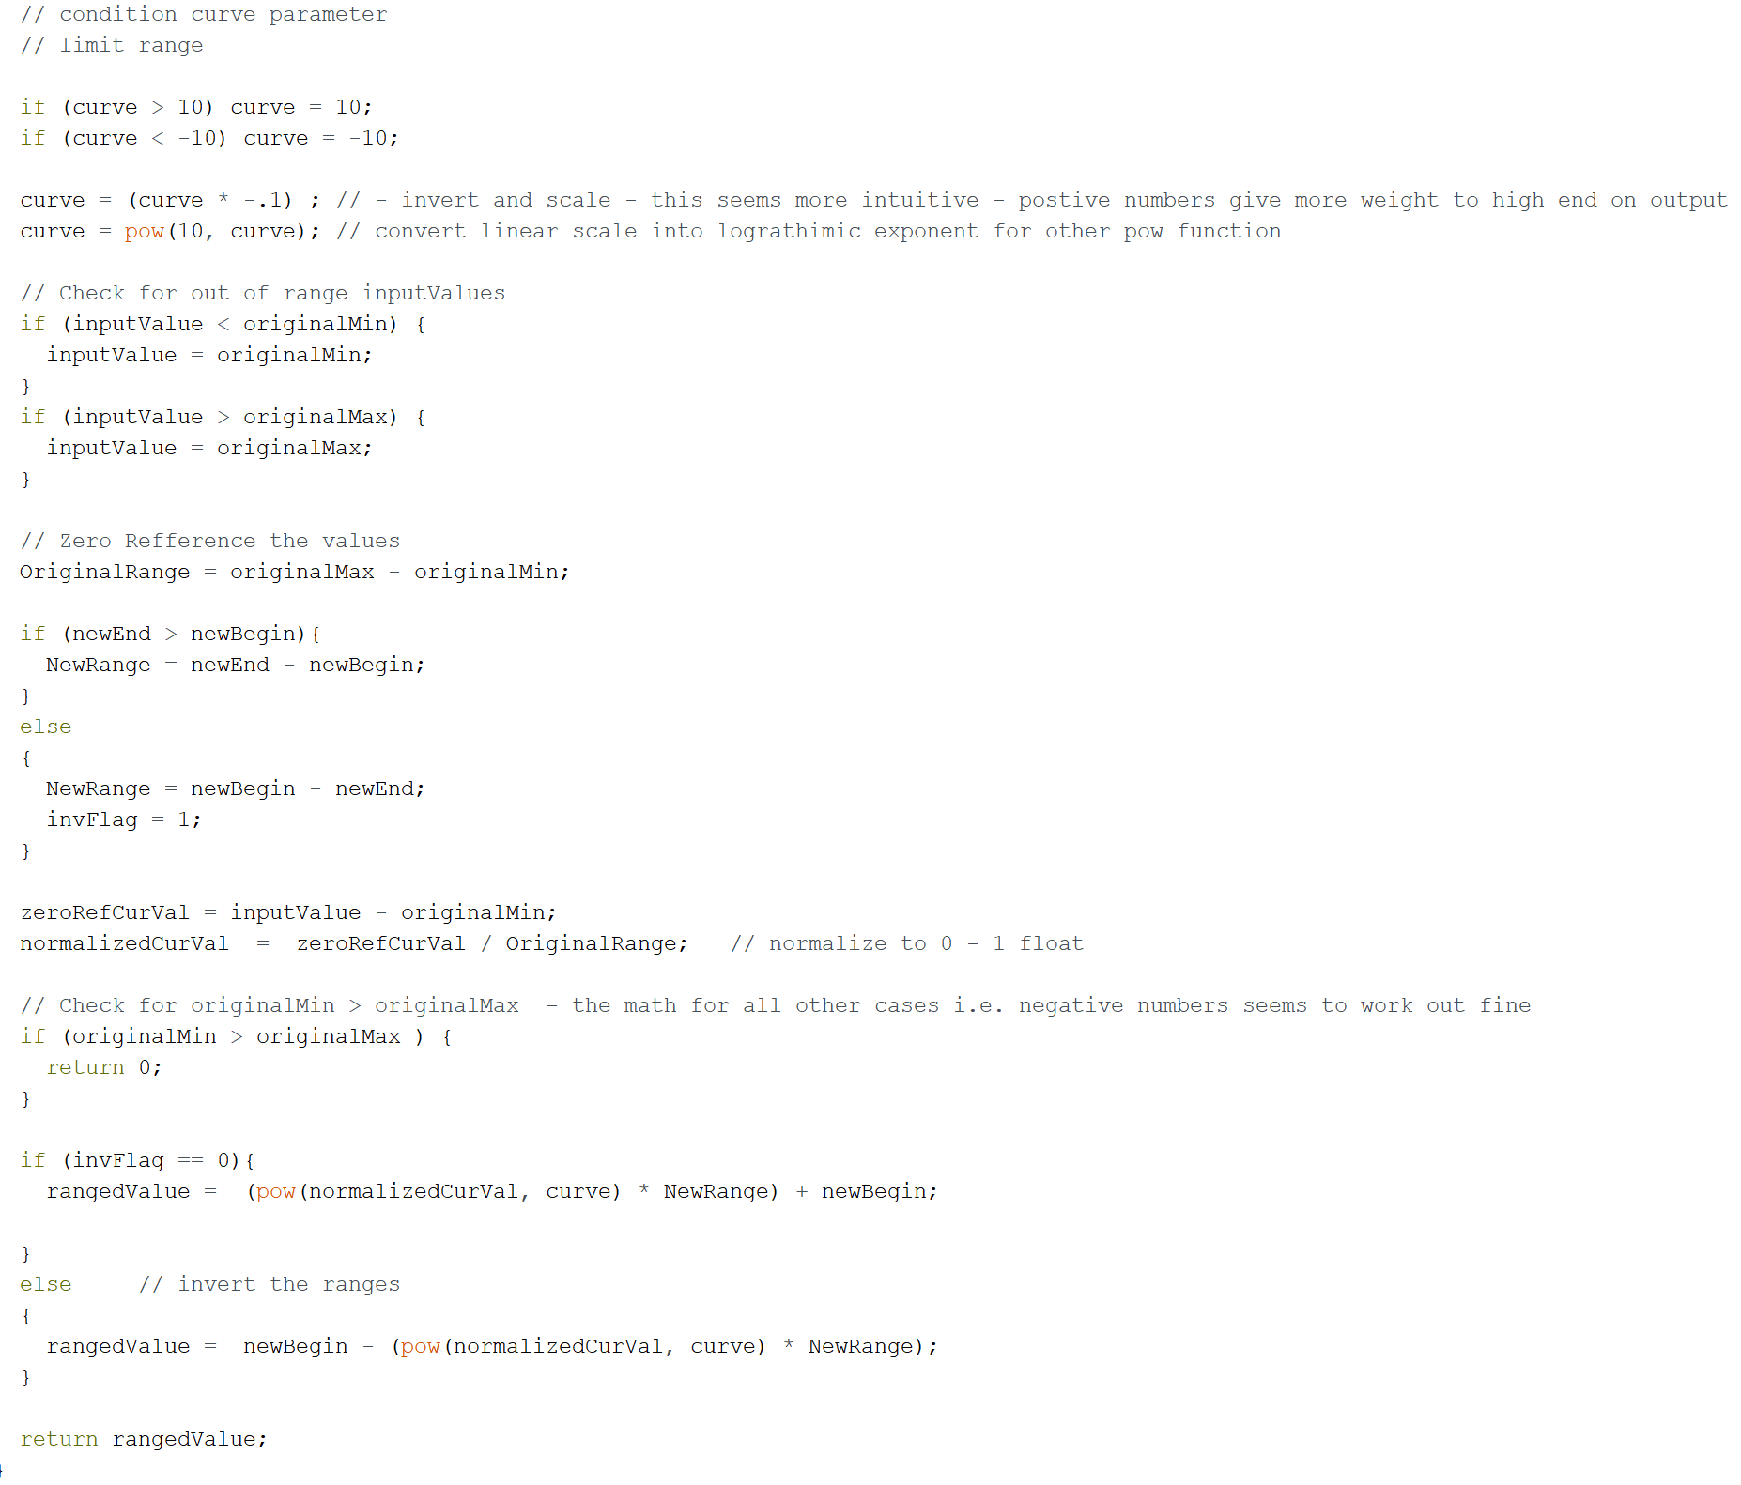

## **11.3 Appendix C: Pugh Chart**

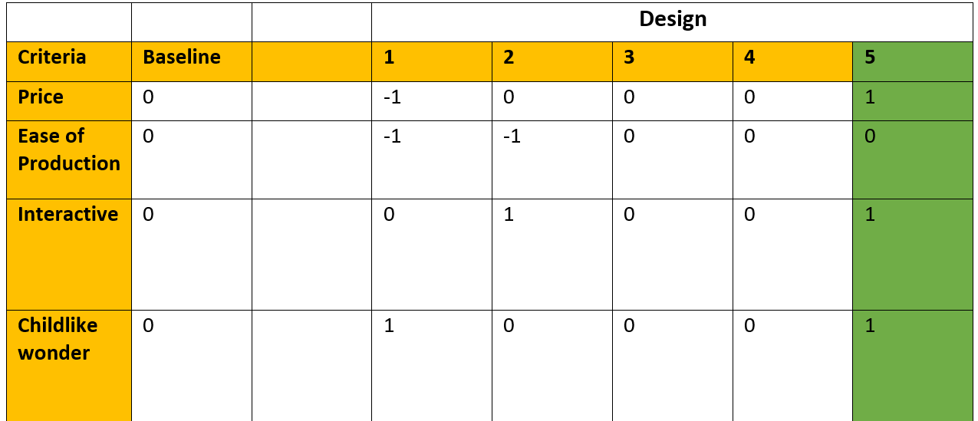

## **11.4 Drawings**

### **5.2.3 Drawings**



Figure 17 - Front Plate

Figure 17 is basically the front part its 26 x 26 in. I talked with Dr.Willy in ME476C and we decided to choose 26x26 in, because we need our box to be good enough not that big and not that small. Also, we wanted the shapes to be projected on the back side. Otherwise, the front and back plates have the same dimensions. Also, there is a hole on the front side because of the wires. The dimension of the hole is 2x2 in. The thickness for the front plate is 0.24 in. The material we are using for the front plate is “Acrylic Sheet”.



Figure 18- Side Plate

Figure 18 shows the side. Sides have the same dimensions. It’s made from “Bronze Tint Acrylic”. The reason why I chose this is because its light to carry, portable, and flexible. Dimensions are 26x26 in. Why I chose 26x26 in is because I need the box to be a little a bit big inside to let kids see what happens inside (process) clearly, and I need a distance between (Arduino and LED light). The thickness for the side plates is 0.24 in. The side plates are attached with the top plate only because they have brackets. The brackets are glued on the top plate and we slided the sides in the brackets. From that the brackets are holding the side plates.



Figure 19 - Top Plate

Figure 19 shows the top side. It’s made from “Bronze Tint Acrylic”. The reason why there is a top plate is to protect the kids from the light rays. Also, to make the projection clear, and the inside should be dark to let the kids see what happens inside the box clearly. The thickness for the top plate is 0.24 in. On this plate we glowed two brackets on each corner to hold the sides, back, and front.



Figure 20 - Back Plate

Figure 20 shows the back plate. It’s made from “Bronze Tint Acrylic”. The reason why there is a back plate is to project shapes on the back. We attached a white sheet on the back plate in order to highlight the shapes. The thickness for the top plate is 0.24 in. This plate is attached with the top plate by using brackets.

Figures 21, 22, and 23 shows three different geometric shapes (circle, hexagon, and a triangle) that are added on each of the three servo motor wings. Each are measured at 1.6 in in diameter. Rotating with the rotational signal of the servo motor and are controlled by the sound coming from the piano keys. The servo motor will be rotating at 0 to 180 degrees and going back.



*Figure 21- Triangle*



*Figure 22- Hexagon*



*Figure 23- Circle*

## 

## **11.5 Appendix D: Bill of Materials**